Unit 9: 1920's & 1930’s Guided Reading Packet
SSUSH16 Investigate how political, economic, and cultural developments after WWI led to a shared national identity.
a. Explain how fears of rising communism and socialism in the United States led to the Red Scare and immigrant restriction.
Rise of Communism and Socialism
The German philosopher Karl Marx developed a new theory in the mid-nineteenth century that combined history and economics. Marx held that history was composed of a series of revolutions in which those who were oppressed overthrew their oppressors and established new political and economic forms. Marx also said that those in power, who ultimately became oppressors themselves, gradually corrupted these new systems. He held that the final revolution would be between the capitalists and the workers. According to Marx, the workers would eventually tire of being oppressed through low wages and poor working conditions and violently overthrow the capitalist economic system. This workers' revolution, he believed, would usher in a new time period. Out of the revolution would come the creation of a dictatorship in which workers would share the means of production and distribution. Marx's theory became known as a more extreme form of socialism, which is known as communism.
The idea of a worker controlled economic system appealed to industrial workers worldwide. In 1901, the Socialist Party of America was created. Elements of socialist theory also infiltrated American labor unions, especially the Industrial Workers of the World (I.W.W). With the exception of the elections of 1912 and 1920, the Socialist Party in the United States was a weak third party. In 1917, communist revolutionaries known as Bolsheviks overthrew the czar in Russia. The new Bolshevik authority established the Union of Soviet Socialist Republics and was led by Vladimir Lenin. Lenin called for a worldwide revolution to destroy capitalism. America thus became a pivotal target for communist infiltration.
Unable to engage in direct action during World War I, labor unions began to strike for higher wages after the war. These strikes, thought by many to be led by communists, became increasingly more violent. The fear of the spread of communism in the United States was heightened by Karl Marx's prediction of a worker revolution. Were the labor union strikes part of Lenin's mission in the United States? Many saw capitalism and democracy as being in danger from communist threats. The wave of fear and action to protect the United States from such ideological crisis became known as the Red Scare. For the most part, Americans were unified to protect the nation's identity as a democratic and capitalist country from communism.
The perceived danger was further exacerbated by a series of bombings sponsored by a group of Italian anarchists. The attacks were carried out against public buildings and officials. Terrorists twice attacked United States Attorney General A. Mitchell Palmer. These incidents, coupled with the violent labor strikes, led the United States Justice Department and the FBI to stage a series of raids against suspected anarchists and communists. Hundreds were arrested across the nation. However, civil libertarians claimed the Palmer Raids lacked legal standing and targeted people's beliefs rather than their actions. Most of those arrested were later released but 556 people were deported as a result of the Palmer Raids. The Red Scare ended when a purported May Day plot to overthrow the government never took place and Palmer's actions were censured for violating civil liberties.
Document Analysis 1
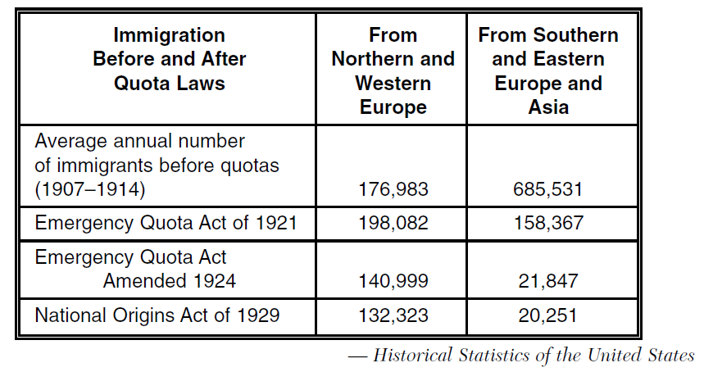
Immigrant Restriction
The Red Scare was also a factor that led to new restrictions on immigration. Other factors included two ideas that grew particularly strong during the post-World War I era of the 1920s. One of the ideas was that people born in the United States were superior to immigrants. The other was that America should keep its traditional culture intact. Anti-immigrant, anti-Jewish, and anti-Catholic sentiments contributed to the popularity of a revived Ku Klux Klan, not just in the South but also throughout the nation. By 1924, this conservative reaction against immigrants resulted in the passage of the National Origins Acts. The main provision of the laws was to establish the Quota System, which set limits on the number of immigrants who could enter the United States from each country. The Red Scare was perceived by many to be a threat to the foundations of the United States. Although sometimes overstepping individual civil liberties, there were strong efforts after World War I to protect and enhance the national identity of the United States.
b. Describe the effects of the Eighteenth and Nineteenth Amendments.
Eighteenth Amendment
Social changes during World War I led to two constitutional amendments. An undercurrent related to the growing national identity of the period can be found in the passage of Eighteenth and Nineteenth Amendments. The Eighteenth Amendment's ban on alcohol is related to pronounced anti-German sentiment during World War I. The Nineteenth Amendment's enfranchisement of women brought with it a greater role for women in shaping the nation's identity.
Americans' anti-German efforts during World War I led to a campaign to outlaw beer and other alcoholic beverages. This effort was well suited to the Progressive Era's opposition to saloons. It became patriotic during the war to abstain from alcohol, not only to preserve grain for the troops and our allies but also as a symbol of resistance to beer's German connection. Congress passed the Eighteenth Amendment in 1917 and it was ratified in 1919. The provisions of the amendment prohibited the manufacture, sale, and transportation of intoxicating liquors.
The effect of the Eighteenth Amendment was not completely positive. Organized crime and smuggling alcohol brought tremendous profits to those willing to break the law for financial gain. Speakeasies and bootleggers profited from the banning of alcohol. In the 1930s the Twenty-First Amendment that made alcohol legal again was ratified. The Twenty-First Amendment repeals, or cancels out, the Eighteenth Amendment. One reason the government was keen on making alcohol legal again was to levy taxes on it during the financial difficulties of the Great Depression
Document Analysis 2
Causes of Prohibition (18th Amendment) | Effects of Prohibition (18th Amendment)
- Various religious groups thought drinking alcohol was sinful  - Reformers believed that the government should protect the public’s health.  - Reformers believed that alcohol led to crime, wife and child abuse, and accidents on the job  - During World War I, native born Americans developed a hostility to German-American brewers and toward other immigrant groups that used alcohol. | - Consumption of alcohol declined.  - Disrespect for the law developed.  - An increase in lawlessness, such as smuggling and bootlegging, was evident.  - Criminals found a new source of income.  - Organized crime grew.
Nineteenth Amendment
The Nineteenth Amendment gave women the right to vote. The women's movement had been actively working toward this goal since the Seneca Falls Convention of 1848. Ratification of the amendment in 1920 was fueled by the country's gratitude for women's economic contribution during World War I. Women had filled jobs in factories after men volunteered and were drafted into military service. The suffrage movement had worked for decades to petition Congress to pass this legislation. Tactics used by suffragettes included demonstrating in front of the White House and driving cross-country motorcades to promote the cause. Eventually, President Wilson supported the women's right to vote, expecting that in return they would support his League of Nations.
The effect of the Nineteenth Amendment was greater equality and independence for women. Gender roles began to change during the 1920s after the ratification of the Nineteenth Amendment. While the amendment itself, is not solely responsible for the cultural changes, the greater political autonomy of women certainly emboldened their social autonomy. Women began to challenge the moral taboos of the Victorian era through their dress, activities, and attitudes.
c. Examine how mass production and advertising led to increasing consumerism, including Henry Ford and the automobile.
Henry Ford and the Automobile, Mass Production, and Advertising
The 1920s was a time of increased consumer buying. People were purchasing new automobiles and household appliances through various means of financing. The new mode of individual transportation changed society by making the population more mobile and able to live greater distances from their jobs. Advertising of cars and new household appliances was largely through nationwide campaigns on the radio, in magazines, and at the movies. People began to see themselves as "needing" certain items of convenience rather than simply "wanting" them.
Henry Ford was the developer of the first mass produced automobile - the Model T. While the idea of mass production was not new, Ford used an improved continuous assembly line to quickly build automobiles. Ford constructed his manufacturing facilities so that all the elements of production (foundries, machine shops, assembly lines) were all in one location. He was also able to speed up production and drive down costs of automobiles by standardizing parts, focusing on specialization of labor, and through careful management. At its introduction in the market, Ford's Model T cost $950. Within ten years, the same model cost $280 due to improved production methods.
The automobile led to huge social changes in America. People began moving to the suburbs because of their widespread ownership of cars. There was also a new need for improved roads and highways. Travel was more independent and vacations for pleasure became popular. As a result new businesses were needed such as gas stations, motels, and roadside restaurants.
d. Describe the impact of radio and movies as a unifying force in the national culture.
Document Analysis 3
“The only problem was that just as we were becoming stars, vaudeville (stage play) was dying. No one could pin the rap on us, though. Everybody believes it was the movies that killed vaudeville. That’s not true. Movies, vaudeville, burlesque, the local stock companies—all survived together.
Then radio came in. For the first time people didn’t have to leave their homes to be entertained. The performers came into their house. Gracie and I knew that vaudeville was finished when theaters began advertising that their shows would be halted for fifteen minutes so that the audience could listen to ‘Amos & Andy’. And when the ‘Amos & Andy’ program came on, the vaudeville would stop, they would bring a radio onstage, and the audience would sit there watching radio.
It’s impossible to explain the impact that radio had on the world to anyone who didn’t live through that time. Before radio, people had to wait for the newspaper to learn what was happening in the world. Before radio, the only way to see a performer was to see a performer. And maybe most important, before radio there was no such thing as a commercial.
Radio made everybody who owned one a theater manager. They could listen to whatever they wanted to.”
Source: George Burns, Gracie a Love Story, 1988
Impact of Radio and Movies
The period after World War I marked the beginning of mass media, especially commercial radio and movies. Although hobby radio had existed since the early years of the Twentieth Century, the development of the vacuum tube, a type of amplifier, in the mid-1920s accelerated the development of commercial radio.
The first radio broadcasts were used to relate the election results of the 1920 Presidential Election. By 1925, there were 600 radio stations across the United States. By 1923, nearly three million Americans had radios. Music, stories, sporting events, and news were soon being broadcast nationwide. A stronger national, rather than regional, identity emerged in the United States.
Radio helped to create a common cultural experience for thousands of Americans. Advertisers were quick to realize the marketing potential of radio. They began using radio to mass market the multitude of consumer goods that were developed in the period, such as washing machines, electric toasters, and laundry soap. Products and brands were becoming more widespread due to the vast market radio offered.
Movies had a similar beginning. The first movies were silent films but by the late 1920s, the first movies with sound were available to audiences. During this era, the movies became big business as studios churned out an average of 800 feature films annually. Conservatives of the time often disapproved of what they viewed as movies' immoral influences. However, the popularity of movies was so widespread that the conservative moral opposition was unable to challenge the entertainment's growing influence on American culture. Radio and movies were a unifying force on national culture because the styles actors and actresses wore, activities they were engaged in, and products they were using was all being watched and listened to by Americans from all parts of the country simultaneously.
e. Describe the emergence of modern forms of cultural expression including the origins of jazz and the Harlem Renaissance.
The Emergence of Modern Forms of Cultural Expression
The 1920s marked a distinct break from the Victorian culture of the previous century. In the visual arts, the Modernist Movement began during the period. European modern artists, whose work was first exhibited in 1913, influenced American artists. These works were impressionistic, abstract, geometric, and represented a break from the schools of romanticism and realism. The era also marked the beginning of the art deco movement. In this new form, artists began to create artistically styled furnishings using modern materials such as aluminum, plastics, and glass. In architecture, the trend of building skyscrapers accelerated.
Literature in the modern era was noted for its themes of alienation and disillusionment. Writers rebelled against traditional constraints and incorporated themes deemed immoral by the previous generation. Most notable were the writers that came out of the Harlem Renaissance.
The Harlem Renaissance marked the first significant artistic movement coming out of Black culture. Centered in the Harlem borough of New York City, the movement produced notable works of literature, music, dance, and visual art. Writers included W.E.B. DuBois and Langston Hughes. Hughes' poetry used the rhythms of Black music, particularly blues and jazz. This allowed Hughes to experiment with a very rhythmic free verse. Harlem's Cotton Club was an important location, where White audiences were exposed to ideas of the Harlem Renaissance - including Jazz.
Performing arts expanded with the advent of radio and movies. As income rose during the period, families had more money available to spend on entertainment. Radio stations needed to fill airtime by broadcasting the latest music to listeners. Jazz was a genre that benefitted from this demand for music.
Although Jazz was not born out of the Harlem Renaissance, it was the first true American music. The musical form was so influential that the era of the 1920s is often referred to as the Jazz Age. Born in the Deep South, Jazz was thought to have originated from the musical traditions brought by slaves from West Africa combined with western musical instruments and techniques. Jazz, as a musical style, is easy to recognize but hard to define. Jazz has elements of different genres of music but is most noted for its improvisations. By the 1920s, there were several different types of Jazz, including Dixieland that originated in New Orleans. Famous Jazz musicians included Louis Armstrong and Duke Ellington. Jazz also influenced composers such as Cole Porter and the Gershwin Brothers who composed Rhapsody in Blue and the Jazz opera Porgy and Bess.
SSUSH17 Analyze the causes and consequences of the Great Depression.
a. Describe the causes, including overproduction, underconsumption, and stock market speculation, that led to the stock market crash of 1929 and the Great Depression.
Causes of the Great Depression
Though the United States' economy appeared to be prosperous during the 1920s, the conditions that led to the Great Depression of the 1930s actually emerged during the previous decade. There is not one specific cause of the Great Depression, but rather a number of contributing factors. The beginning of the Great Depression is often pinpointed as the Stock Market Crash of October 1929. This event triggered the various contributing factors into a downward spiraling economy that left many Americans unemployed and suffering in desperate poverty.
While many European nations suffered a post-World War I recession, the United States did not. American businesses, farms, and banks profited greatly during World War I by selling products to European markets. However, by 1929, the economic boom for the United States was over and the Great Depression began. There are numerous causes that together led to the severity of the Great Depression.
The causes of the Great Depression were:
1. Industrial overproduction- Industries increased their productive capacity to produce and sell more goods. As a result, a supply surplus was created. This problem became exacerbated by Europe's struggling post-war market. The European countries could not buy as much American made product due to their own financial difficulties. The United States had more goods than consumers.
2. Consumer overspending - With cash to spend after the war, Americans went on a spending spree. The development of the national consumer market in the United States and the advent of consumer credit further encouraged spending. After the Stock Market collapse in October 1929, consumers quit spending except for absolute necessities creating a surplus of goods in the market place. This caused Under-consumption, which deepened the economic slowdown.
3. "Get rich quick" attitudes - Investors sought to maximize their wealth through speculation in real estate and the stock market. To obtain capital for expansion, companies began to offer more shares of stock for sale. Seeing growing demand for stock translate into growing value of stock shares, speculators began to buy and sell stocks quickly to profit from the rising market. Buyers were allowed to borrow money to purchase stocks with as little as 10% down. The gamble for buyers paid off as long as stock prices continued to rise. When the prices fell, these stock buyers were in debt to their stockbrokers with no way to pay off what they owed. Eventually, the speculators began to sell off stock to make profits and touched off a run on selling. The large numbers of stocks sold at the same time led to the Stock Market Crash of October 1929.
4. Disparity in Wealth- While many Americans prospered during the 1920s, some economic sectors did not. Farmers lost income throughout the 1920s because European markets stopped buying American farm goods. Coal mining suffered as oil began to replace coal as a fuel. In general, workers' wages failed to keep pace with prices during the period. As a result, an unequal distribution of wealth developed. The richest 1% of the American population owned approximately 40% of the country's wealth.
5. Banking Panic- As unemployment increased, depositors began to withdraw more and more of their savings from their bank. Lacking sufficient reserves, banks were forced to call in loans, which in turn touched off a wave of bankruptcies. Unable to collect outstanding loans, banks began to fail. In all, 9,000 banks failed during the 1930s. Many people lost their life savings. The bank failures led to a demand for more cash in the economy, which contradicted the Federal Reserve policy of the era. The shortage of cash in circulation worsened the effects of the economic downturn.
With all of these factors in play simultaneously, the Great Depression began and continued to get worse. A capitalist system naturally has dips in the economic cycle. However, the events of the 1920s (overproduction, under-consumption, and the Stock Market Crash) made the crisis far more severe than a normally occurring downturn.
b. Explain factors (include over-farming and climate) that led to the Dust Bowl and the resulting movement and migration west.
The Dustbowl
The Dust Bowl is a symbol of overproduction and was a contributing factor to the economic decline of the 1930s. The Dust Bowl originated in the southern plains of the United States. Farmers first arrived in the region at the end of the Nineteenth Century. The Homestead Act and the region’s rich soil drew them west at that time. Farmers in the region talked of the rich, fertile soil and were soon producing high yield crops of wheat, corn, cotton, and livestock. However, unknown to the farmers, the Great Plains region experiences regular wet and dry weather cycles.
The southern Plains were in a wet period when farmers first arrived. Spurred on by the soil's fertility and strong demand for grain during World War I, farmers planted thousands of acres of marginal land in crops. Beginning in 1931, the region entered into a dry cycle. The drought was the worst in United States history, covering more than 75% of the country and severely affecting 27 states.
Year after year, farmers continued to plant wheat and cotton despite the failure of crops. Deep plowing killed the prairie grassed that held together the topsoil. Winds soon began blowing the dry topsoil away. Dust clouds formed that were thousands of feet high and miles wide. The dust storms and drought lasted nearly ten years.
Although two-thirds of families remained in the region, a large group of sharecroppers and tenant farmers left the farms of Oklahoma, Texas, and eastern Colorado and settled in the central California farming region. Without money, many became migrant farm workers who worked the vegetable, fruit, and cotton harvests of the west coast. The migrants became known as "Okies" and were the subject of John Steinbeck's popular book, The Grapes of Wrath. The Dust Bowl eventually ended in 1938, when rains returned and the Soil Conservation Act was passed encouraging better plowing methods in the region.
Document Analysis 4
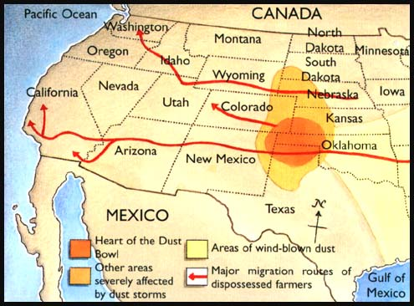
c. Explain the social and political impact of widespread unemployment that resulted in developments such as Hoovervilles.
Document Analysis 5
“. . . Kentucky coal miners suffered perhaps the most. In Harlan County there were whole towns whose people had not a cent of income. They lived on dandelions and blackberries. The women washed clothes in soapweed suds. Dysentery bloated the stomachs of starving babies. Children were reported so famished they were chewing up their own hands. Miners tried to plant vegetables, but they were often so hungry that they ate them before they were ripe. On her first trip to the mountains, Eleanor Roosevelt saw a little boy trying to hide his pet rabbit. “He thinks we are not going to eat it,” his sister told her, “but we are.” In West Virginia, miners mobbed company stores demanding food. Mountain people, with no means to leave their homes, sometimes had to burn their last chairs and tables to keep warm. Local charity could not help in a place where everyone was destitute. . . .”
Source: Kentucky Coal Miner during Great Depression
Consequences of the Great Depression
By 1933, twenty-five percent of the labor force was unemployed in the United States and millions more could only find part time jobs. In 1932, Fortune Magazine reported that 34 million people belonged to families with no regular, full-time wage earner. There were two million homeless people migrating around the country. Women and minorities were especially hard hit. Women, many of whom were single parents, were often fired because many businesses felt jobs should go to men first. Blacks were often the first laid-off only to be replaced by White workers. Children were often malnourished. While there were some public assistance programs and private charities, they were quickly overwhelmed by the sheer numbers of those who needed assistance. Men abandoned their families to search for work and, when they were unable to find a job, did not return home out of shame. Some teenagers were asked to leave home and find a job to support themselves when their families were increasingly unable to do so. Homeless families, lacking shelter, used cardboard and packing crates to create encampments called Hoovervilles. The name was meant to cast criticism on President Hoover and his handling of the economic crisis.
While in office, Herbert Hoover attempted to diminish the impact of the Great Depression by creating work relief programs that included the construction of the Golden Gate Bridge and the Boulder (later Hoover) Dam. He attempted to slow home foreclosures by asking the Federal government to guarantee home loans. However, his programs appeared to the public as too little, too late. He had been reluctant to involve the government early in the economic crisis. It was not until the situation was severe that he began to act and at that point his efforts had minimal impact.
In 1932, Hoover ran for re-election. The Democratic candidate for President was Franklin D. Roosevelt, who publicly blamed Hoover for the Great Depression. Hoover lost the election by a very wide margin, obtaining only 39.7% of the popular vote compared to Roosevelt's 57.4%.
In the first presidential election during the Great Depression, American voters rejected Herbert Hoover and voted in the Democratic candidate Franklin D. Roosevelt. The new President used the name "New Deal" to refer to his series of government-funded programs to end the Depression. Roosevelt promised these programs would help different segments of the economy recover by addressing specific needs and weaknesses. The New Deal did create jobs for the unemployed and provide relief to people struggling during the economic crisis. However, Roosevelt's programs did not end the Great Depression. The outbreak of World War II and the production demand the war brought with it ended the Great Depression. Roosevelt's New Deal provided relief and stalled the downward economic spiral the country faced under Hoover's limited federal response to the economic crisis. Some New Deal programs were more successful than others and some groups in the United States benefitted more than others from Roosevelt's efforts.

SSUSH18 Evaluate Franklin D. Roosevelt’s New Deal as a response to the Great Depression and compare how governmental programs aided those in need.
a. Describe Roosevelt’s attempts at relief, recovery, and reform reflected in various New Deal programs.
Document Analysis 6
Relief: immediate action taken to halt the economies deterioration.
Recovery: “Pump-priming” temporary programs to restart the flow of consumer demand
Reform: Permanent programs to avoid another depression and insure citizens against economic disasters
Source: The 3R's of Franklin Roosevelt's New Deal Plan
The New Deal
When Franklin Roosevelt took his oath of office in March 1932, the nation was in grave crisis. Five thousand banks had closed. Unemployment hovered at twenty-five percent. Corporate profits had fallen to ninety percent and farm commodity prices had fallen sixty percent. Two million Americans were homeless. As a result of these issues and President Hoover's reluctance to appropriate Federal assistance, the American public had lost confidence in its government. Roosevelt's plan was to immediately provide relief to those struggling the most, recovery for the economic systems damaged by the economic crisis, and reform so that there would not be another Great Depression. His program of relief, reform, and recovery was known as the New Deal. Roosevelt's first one hundred days in office was a declaration of war on the Great Depression. The new president immediately signed an executive order closing all banks in the United States temporarily until their solvency could be determined. He also called Congress into special session and sent the legislative body a series of bills designed to address the nation's problems. Collectively, these bills became known as the New Deal.
Some of the relief measures included the Federal Emergency Relief Administration (FERA) that granted federal money to state and local governments for operating soup kitchens and meeting the basic needs of the homeless. There were also a number of agencies created during the first few months of Roosevelt's administration that were intended to put people to work on government funded projects. Examples of the First New Deal's work agencies include the Public Works Administration (PWA) that provided money to states for the construction of roads, bridges, and dams. The Civilian Conservation Corps (CCC) hired young men to work on land projects. Another large program funded by the Federal government was the Tennessee Valley Authority (TVA), which hired thousands of workers in the very rural Tennessee Valley to build dams, power plants, and work to control flooding and erosion.
Other significant features of the New Deal were intended to help the financial systems recover from the Great Depression. The Federal Deposit Insurance Corporation (FDIC) was created to shore up public confidence in the banking system. The FDIC provided insurance on individual bank accounts with deposits up to $5000. Farmers were granted subsidies through the Agricultural Adjustment Act (AAA), which would help recover crop prices by cutting production.
One major area of reform dealt with the Stock Market. The Securities and Exchange Commission (SEC) was created to regulate the Stock Market. The intent was to prevent another stock market crash by limiting the types of stock speculation that could be transacted.
All of these programs and organizations created significant government involvement in the economic system of the United States. This was quite a departure from the long history of the nation, which had typically followed a laissez-faire approach (other than the trust busting of the Progressives). In evaluating the programs of the New Deal, one has to consider both the immediate and long-term effects. In the short term, programs such as the CCC, PWA, and TVA put thousands of unemployed Americans back to work. However, much of the work available was hard, physical labor that benefitted young men and did not help some groups such as women or the elderly. The emergency banking measures and the creation of the FDIC helped to restore public confidence in America's financial institutions. The long term implications of these programs was not fully realized since America's involvement in World War II lifted the nation out of the economic crisis with the unprecedented production demands that benefitted businesses and ended unemployment.
b. Explain the passage of the Social Security Act as a part of the second New Deal.
Second New Deal
Entering his second term as President, Roosevelt believed a Second New Deal was needed. He believed more needed to be done to address the needs of groups who did not directly benefit from the First New Deal. One such group was the nation's senior citizens. Most seniors did not have pensions and those who did saw them wiped out as a result of the Great Depression. The agencies of the First New Deal did not offer the elderly opportunities for work.
Roosevelt signed into law the Social Security Act in 1935. The new law provided for old-age pensions, unemployment insurance, and aid to the disabled. The first version of Social Security excluded many groups including agricultural workers, teachers, domestic help, and children. As a result, the act excluded many Blacks and women. These concerns were addressed in subsequent amendments to the Social Security Act. The program is still in effect today.
c. Analyze political challenges to Roosevelt’s leadership and New Deal programs.
Document Analysis 7
“Now, my friends, when this condition of distress and suffering among so many millions of our people began to develop in the Hoover administration (Great Depression), we knew then what the trouble was and what we would have to do to correct it. I was the first man to say publicly -- but Mr. Roosevelt followed in my tracks a few months later and said the same thing. We said that all of our trouble and woe was due to the fact that too few of our people owned too much of our wealth. We said that in our land, with too much to eat, and too much to wear, and too many houses to live in, too many automobiles to be sold, that the only trouble was that the people suffered in the land of abundance because too few controlled the money and the wealth and too many did not have money with which to buy the things they needed for life and comfort.
So I said to the people of the United States in my speeches which I delivered in the United States Senate in the early part of 1932 that the only way by which we could restore our people to reasonable life and comfort was to limit the size of the big man's fortune and guarantee some minimum to the fortune and comfort of the little man's family.”
Source: Huey Long’s “Share the Wealth” Speeches Part One, March 1935
New Deal Challenges: Huey Long
During his twelve-year presidency, Franklin Roosevelt faced many challenges to his leadership and had many critics. Opponents of the New Deal came from all parts of the political spectrum. Some conservatives thought he had made the government too large and too powerful. These conservatives also felt some aspects of the New Deal did not respect the rights of individuals and property. However, some liberals thought Roosevelt had not gone far enough to socialize the economy and eliminate inequality in the United States.
Perhaps Roosevelt's biggest critic was Senator Huey P. Long of Louisiana. Long was planning to challenge Roosevelt for the presidency in 1936 until he was shot and killed by an assassin the year before the election. Senator Long was one of those critics who believed the New Deal had not gone far enough in its efforts to help society. Instead of the New Deal, Long proposed what he called the "Share Our Wealth" program. The plan would guarantee a household income for each family in the United States, which would be paid for by high taxes on the wealthiest Americans. Long in effect was planning to take from the rich to give to the poor.
Leadership Challenges: Court-Packing Bill
In addition to the New Deal challenges issued by Huey Long and others, the Supreme Court declared two pieces of the First New Deal unconstitutional in 1936. One was the National Industrial Recovery Act, which attempted to guarantee fair wages and hours for workers. The other was the Agricultural Adjustment Act, which was going to grant farmers subsidies to cut their production in an effort to stabilize crop prices. The Court struck down these two programs because they were perceived as Federal overreach into the operations of private businesses.
Roosevelt grew increasingly frustrated with the Supreme Court, which was composed of nine men, all over 60 years old and conservative. He felt the Court was "thwarting the will of the nation." Roosevelt informed his cabinet at a special meeting that he would send a message to Congress proposing the reorganization of the federal judiciary system. The plan was ostensibly designed to "improve the efficiency of the entire system" by adding judges to all levels of the federal courts and adopting procedures to expedite the appeals process. The actual intent of the plan was obvious. By adding a judge to the Supreme Court for every justice who refused to retire after the age of 70, Roosevelt could appoint enough justices to uphold his New Deal programs.
Franklin Roosevelt was criticized for wanting to "pack the court." His opponents believed he was attacking the independence of the judiciary and subverting the Constitution. Many of Roosevelt's longtime supporters deserted him on this controversial proposal. The opposition Roosevelt received to this proposal began to sour the nation on the New Deal.
Document Analysis 8
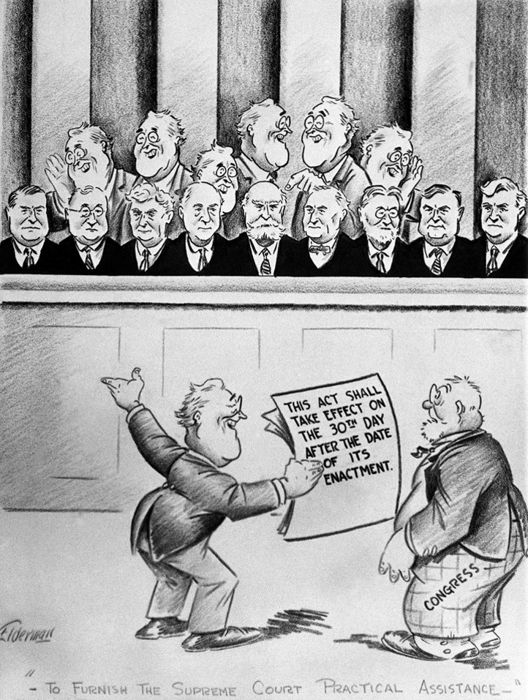

Leadership Challenges: U. S. Neutrality
As Roosevelt and Congress battled the Great Depression at home, the US kept a watchful eye on events overseas as well. In Europe, militaristic dictators rose to power in Germany and Italy and threatened to lead the entire continent back into war. Meanwhile, across the Pacific, Japan seized parts of China and threatened to continue expanding their Southeast Asian empire by military force. Despite these concerns, however, the United States continued to practice isolationism. The devastation of WWI left many in the U.S. unwilling to become involved in another international conflict, while the economic effects of the Great Depression meant many U.S. citizens wanted their government concerned with fixing problems at home rather than abroad. Responding to this isolationist sentiment, Congress passed the Neutrality Act in 1935. This act prohibited the sale of weapons to warring nations and was meant to keep the U.S. from forming alliances that might drag the nation into war. Anti-war feeling was so strong that Congress introduced an amendment to the Constitution requiring a national vote before the U.S. could declare war. It failed by a narrow margin. Meanwhile, Roosevelt became more and more convinced that the United States could not continue to stay out of international conflicts much longer.

d. Examine how Eleanor Roosevelt changed the role of the First Lady including development of New Deal programs to aid those in need.
Role of Eleanor Roosevelt
President Roosevelt's wife, Eleanor, was very influential in her own right. She was the first president's wife to testify before a Congressional committee, the first to hold press conferences, to speak before a national party convention, to write a syndicated newspaper column, to be a radio commentator, and to earn money as a lecturer.
Eleanor Roosevelt was interested in humanitarian causes and social progress. She was very vocal about these issues with her husband during his time in the White House and urged him to create reforms to help minorities and the poor. Eleanor traveled all over the United States to observe social conditions so she could keep the president informed as to the state of the nation. President Roosevelt referred to Eleanor as "his legs," since his mobility was severely limited by the crippling effects of polio.
As a vocal advocate for both women and Blacks, Eleanor Roosevelt was instrumental in ending discriminatory practices associated with New Deal legislation. As a supporter of women's activism, she was also instrumental in convincing President Roosevelt to appoint more women to government positions. Following World War II, Eleanor Roosevelt became known as "First Lady of the World" due to her service with the United Nations. Some historians credit Eleanor's actions with changing Black voters from supporting Republican candidates to supporting Democrats. She is also credited with changing the role of First Ladies from that of passive spouses to women who use their position of influence to address societal issues. Eleanor Roosevelt took action as a First Lady and that tradition has continued.

