Unit 8: American Imperialism and WWI Guided Reading Packet
SSUSH14 Explain America’s evolving relationship with the world at the turn of the twentieth century.
a. Describe how the Spanish-American War and territorial expansion led to the debate over American imperialism.
Document Analysis 1
American Imperialism
As the United States industrialized, businessmen began to look overseas for additional markets, sources of raw materials for future developments, and potential investment. As a young nation, many Americans felt that the United States should emulate the European nations with their colonies in Africa and Asia. Many also believed the United States should build up its Naval capacity to protect national interests. In an effort to obtain overseas markets and spread democracy, these expansionists wanted the United States to establish territories overseas before the European nations acquired any additional colonies. The first overseas opportunity for the United States came with the acquisition of Alaska from Russia in 1867. Closer to home, the United States began to pursue interests in the Caribbean, which ultimately led the nation into a war against Spain.
The United States had long had an interest in Cuba. Throughout the 19th century, the Cubans had tried to overthrow Spanish rule but had been met with defeat each time. In 1895, a new revolution broke out. Spain responded with great force and brutality. Angered over the harsh treatment of the Cubans and fearful of losses to millions of American investments in Cuba, many Americans demanded action against Spain. The United States responded by sending the battleship Maine to the shores of Cuba. On February 15, 1898, the battleship exploded and sank in Havana Harbor. The incident killed 250 officers and men on the ship. Newspapers in the United States demanded military action against what was perceived as an act of war. President McKinley was reluctant to declare war on Spain without clear evidence of Spanish involvement in the Maine’s destruction. A leading newspaper then published a letter stolen from the Havana post office. The Spanish minister to the United States, Enrique DeLome, wrote the letter. The “DeLome Letter” criticized President McKinley and angered many Americans, who began to clamor for war. War was ultimately declared against Spain.
Document Analysis 2
DESTRUCTION OF THE WAR SHIP MAINE WAS THE WORK OF
AN ENEMY
Assistant Secretary Roosevelt Convinced the Explosion of the War
Ship Was Not an Accident.
The Journal Offers $50,000 Reward for the Conviction of the
Criminals Who Sent 258 American
Sailors to Their Death.
Naval Officers All Agree That the Ship Was Destroyed on Purpose.
NAVAL OFFICERS THINK THE MAINE WAS DESTROYED BY A
SPANISH MINE.

Source: New York Journal and Advertiser: February 17, 1898
Spanish-American War
The initial phases of the Spanish-American War actually began in the Pacific, rather than in Cuba. Since 1882, the United States Navy had undergone a modernization campaign that resulted in the creation of a two-ocean fleet. Assistant Secretary of the Navy, Theodore Roosevelt, positioned ships near the Philippines prior to the declaration of war. When war was declared, Roosevelt ordered the Navy to immediately proceed to the Philippines. The U.S. Navy surprised the anchored Spanish ships and destroyed them. After the naval operation, the United States moved quickly to bring land forces to the Philippines.
The United States Army was not prepared for an overseas war. Numbering only 28,000 men, the Army was mainly composed of veterans of the Plains Indian War. Between the April 25th declaration of war and early summer, the Army grew to 220,000 men. The new soldiers had to be quickly trained, clothed, armed, and transported to Cuba. While the army prepared, the U.S. Navy blockaded the Cuban coast, trapping Spain’s Atlantic Fleet. The U.S. Army landed in Cuba and began its advance. However, Spanish forces were better armed and had more combat experience than the Americans. As a result, the American advance slowed to a crawl allowing the Spanish to create a fortified line in the hills around Santiago, Cuba. Due to the determined efforts of the U.S. Army, including four regiments of Black troops and Theodore Roosevelt’s all-volunteer unit known as “The Rough Riders”, the Americans forced the Spanish to retreat. The Spanish fleet sailed out into the waiting guns of the American fleet and was destroyed. Meanwhile, other American units captured Puerto Rico.
The 1898 Treaty of Paris ended the war. Under the provisions, Spain agreed to grant Cuba independence. The Caribbean island of Puerto Rico and the Pacific island of Guam were ceded to the United States. The final provision granted the United States acquisition of the Philippines for a token $20 million. Debate quickly began over the United States’ new empire. How should it be governed and does the concept of American imperialism match with the basic founding principles of the United States?
Philippine-American War
Prior to the United States' entry into the war, Spain had refused to grant independence to Philippine rebels, who were fighting the European nation in a revolutionary war. The U.S. Navy quickly defeated the Spanish navy and questions immediately began about what to do with the Philippines. Americans debated whether the United States should expand its territory to include the Philippines or respect Filipino independence. The United States decided to administer the islands as a territory because officials were afraid a free and independent Philippines would be a weak nation vulnerable to foreign take over.
Angered by the United States’ decision, Filipino freedom fighters under the leadership of Emilio Aguinaldo continued their fight. This time, the fight was against the United States in what is known as the Philippine-American War. By 1902, the guerrilla forces were defeated and the United States began administration of the islands, gradually releasing control until final independence of the Philippines occurred in 1946.
Debate Over Territorial Expansion
The United States Congress had debated and rejected the annexation of Hawaii many times since 1893, when a group of American businessmen led a rebellion against the Hawaiian monarch and petitioned to become part of the United States. The prize naval base at Pearl Harbor had been leased by the United States for decades and it proved to be crucial to naval operations in the Pacific during the Spanish-American War. As a result, Congress considered the value of this resource and annexation of Hawaii was approved in 1898.
The acquisition of the new territories of Hawaii, the Philippines, Guam, and Puerto Rico prompted an intense debate over American expansionism. Several prominent Americans including Williams Jennings Bryan, Mark Twain, and Andrew Carnegie founded the American Anti-Imperialist League. The League opposed the annexation of the Philippines on grounds that it was the antithesis of America’s founding principles. The League launched a series of court challenges regarding the right of the United States to rule areas outside of the continental United States. Others believed that the expansion of the United States beyond its North American boundaries was important for trade, diplomatic power, and national defense. Ultimately, the court rulings created a stratification of territories in which some could, at some future date, become states (e.g., Puerto Rico, Hawaii, and Alaska) and some would not (e.g., Philippines).

b. Examine U.S. involvement in Latin America, as reflected by the Roosevelt Corollary to the Monroe Doctrine and the creation of the Panama Canal.
Panama Canal
Following the end of the Spanish-American War, the United States was in an excellent position to take advantage of markets throughout Latin America. The centerpiece of this development was the construction of a trans-oceanic canal between the Pacific and Atlantic Oceans, known as the Panama Canal. There were three basic reasons for a canal. First, the United States needed to shorten the sailing time between the east and west coast. Second, national defense officials needed to facilitate faster movement of U.S. naval assets from one ocean to another. The final reason was that the United States needed to protect its new holdings in the Pacific.
Earlier attempts to build a canal in Central America by both French and U.S. companies had been failures. In 1903, following diplomatic maneuvering by the United States, the construction of the Panama Canal was attempted again. The United States had to overcome difficult terrain and tropical illnesses to build the canal. The effort was a success and the Panama Canal opened to Naval ships in 1914.
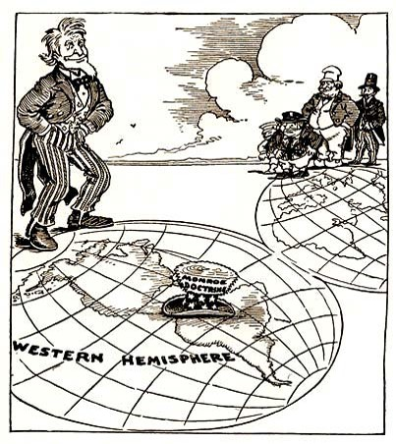
Document Analysis 3 Document Analysis 4
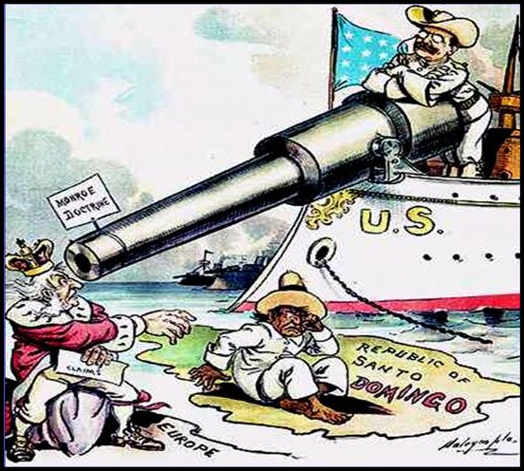
Roosevelt Corollary to the Monroe Doctrine
To protect the canal and U.S. regional interests, Theodore Roosevelt issued what became known as the Roosevelt Corollary to the Monroe Doctrine (usually shortened to the Roosevelt Corollary). In 1902 Venezuela was threatened with invasion by Great Britain and Germany over the nation’s inability to pay back loans to the banks of each respective nation. Roosevelt, fearing European encroachment in Latin America, reminded the Europeans that the U.S. held to the Monroe Doctrine of 1823. In 1904, Roosevelt stated that the Europeans were not welcome in the region and the U.S. would oversee the collection of any national debts owed by Latin American nations to Europeans. In essence, the U.S. would intervene in Latin American countries to prevent their takeover by any other nation.
The Roosevelt Corollary became a key component of Roosevelt’s “Big Stick” policy. President Roosevelt based his foreign policy on the idea of “Speak softly and carry a big stick; you will go far.” Roosevelt believed that negotiations (speak softly) were key to any relationships. But, if negotiations were not fruitful, then the United States would use its military to enforce order (big stick). Invoking the Corollary, the United States intervened in the Dominican Republic in 1904, Nicaragua in 1912, and Haiti in 1915. The policy pleased businessmen in the United States and Great Britain. However, the Roosevelt Corollary angered Latin Americans who felt that the United States did not have the right to intervene in their affairs.

SSUSH15 Analyze the origins and impact of U.S. involvement in World War I.
a. Describe the movement from U.S. neutrality to engagement in World War I, including unrestricted submarine warfare and the Zimmerman Telegram.
U.S. Neutrality
In August 1914, war broke out in Europe with Austria-Hungary and Germany on one side and France, Great Britain, and Russia on the other side. The intense fighting soon spread beyond the fields, forests, and hillsides of Europe to include the seas around Western Europe and out into the eastern Atlantic. In the United States, tensions ran high, especially as newspapers reported on the destruction and loss of life in Belgium, a neutral country. Americans, who in large part came from the nations at war, tended to support their native lands. President Woodrow Wilson was worried that supporters of each side would drag the United States into the war. Furthermore, Wilson worried that violence might occur in the United States between Americans supporting one side or the other. To calm the potential for violence, Wilson went before Congress on August 19, 1914 to ask for a declaration of neutrality, stating that, “The United States must be neutral in fact, as well as in name….”
Even with the Congressional declaration of neutrality, the actions of the United States tended to favor the Allies (i.e., the British and the French). The United States was in a recession in 1914. American businessmen and farmers saw the war as a business opportunity. The United States was eager to trade throughout Europe, but the British had established a blockade not only against German ports but neutral ports as well. Bethlehem Steel was soon sending munitions to England, while the Morgan Bank provided loans that were used by the French and British to pay for war goods. By 1917, American loans to the Allies soared to $2.25 billion; loans to Germany stood at a paltry $27 million.
Germany also relied heavily on imported foodstuffs to feed its population and chemicals for its industries. The British Royal Navy outnumbered the German Imperial Fleet and was able to place an effective blockade on Germany’s Baltic Sea ports, as well as neutral ports in northwest Europe. By early 1915, Germany decided to expand submarine attacks from strictly Allied warships to also include any commercial ships belonging to both belligerent and neutral nations. This action began what is known as unrestricted submarine warfare. America's neutrality was in jeopardy.
Document Analysis 5
“Property can be paid for; the lives of peaceful and innocent people cannot be. The present German submarine warfare against commerce is a warfare against mankind. The German policy has swept every restriction aside. Ships of every kind, whatever their flag, their character, their cargo, their destination, their errand, have been ruthlessly sent to the bottom of the ocean without warning. American ships have been sunk (The Lusitania), American lives taken.
I advise that the Congress declare the recent actions of the Imperial German Government to be, in fact, nothing less than war against the Government and people of the United States. Neutrality is no longer.”
Source: President Woodrow Wilson, in a speech before Congress, April 2, 1917.
Reasons for Entering World War I
German submarines were very effective, sinking an average of two ships each day in the first quarter of 1915. To counter German successes, the British admiralty ordered British cargo ships to fly a neutral flag. The British sometimes loaded critical materials aboard fast liners and other passenger ships, believing the Germans would not dare sink a passenger ship. German commanders ignored the ruse and sank all shipping vessels. In March 1915, the first American was killed off the British coast. The United States reacted with outrage. Attacks on ships carrying Americans increased until May 1915, when the British liner Lusitania was sunk off the Irish coast. There were 128 Americans on board the Lusitania and all were killed. President Wilson reacted by issuing a series of notes to Germany warning against further attacks on American shipping. Germany acquiesced but then on August 19, 1915 the Arabic was sunk, killing three Americans. The Germans feared that the United States would declare war and ordered submarine commanders to cease attacks on passenger liners.
The year 1916 proved critical for both the Allies and Germany, who suffered heavy casualties in a series of failed offensives. The German High Command decided to renew unrestricted warfare to force the British to sue for peace. The Germans believed that they would have six months to complete operations before the United States would declare war. President Wilson was re-elected in 1916 on a peace platform and offered to meditate peace talks between the warring nations the next year.
Unrestricted submarine warfare was renewed in February 1917. Anticipating reaction by the United States, the German government instructed its ambassador to the United States to approach the Mexican government and ask them to join Germany in a war against the United States. The telegram was sent by Germany's foreign minister, Arthur Zimmerman, and was not favorably received by the Mexican government. The secret communication was intercepted by British intelligence and given to President Wilson. American neutrality was no longer prudent. The security of the United States was being threatened.
In February 1917, President Wilson responded to German attacks and threats by severing diplomatic relations with Germany. Public opinion in the United States was split over whether to get involved in the European war. Some groups favored continuing the neutrality policy. Some groups favored war and loyalty was divided between both sides. However, when the Zimmerman Telegram was published in the newspapers, American public opinion swelled to support war against Germany. The President reluctantly knew after this point, war with Germany was inevitable. Despite his reticence, Wilson went before Congress on April 2 to ask for a declaration of war, which was granted.
b. Explain the domestic impact of World War I, including the origins of the Great Migration, the Espionage Act, and socialist Eugene Debs.
Document Analysis 6
One-Way Ticket
I pick up my life and take it with me and I put it down in Chicago, Detroit, Buffalo,
Scranton, Any place that is North and East- and not Dixie.
I pick up my life and take it on the train to Los Angeles, Bakersfield, Seattle, Oakland,
Salt Lake, any place that is North and West-and not South.
I am fed up with Jim Crow Laws, people who are cruel and afraid.
By: Langston Hughes
Domestic Impact of WWI
World War I impacted Americans in a number of ways. The war increased the power of the Federal government and changed the demography of the United States. America was impacted economically, politically, and socially by the nation’s involvement in World War I.
The Wilson administration moved to centrally organize the United States’ economy during World War I with the creation of a series of wartime boards. These boards oversaw production in factories, mediated labor disputes, and improved railroad operations. The private businesses were managed more closely by the government during the war in order to ensure domestic production met the military needs. To finance the war, the United States borrowed from the American people by selling Liberty Bonds. These bonds accounted for two-thirds of the war’s cost. In addition to borrowing, the United States also increased income and excise taxes.
The Espionage Act
President Wilson was correct in his assessment of the American people when he said every man would pay a penalty for non-conformity. In June 1917, at the request of the Wilson administration, Congress passed the Espionage Act. The law provided penalties for spying, sabotage, and obstructing the war effort. The law also banned the use of the United States Mail to send anti-war materials. On June 30, 1918 Eugene Debs was arrested after making a series of speeches against the war urging American men not to fight. He was a prominent Socialist, four-time candidate for the presidency, and union leader. The courts convicted Debs under the Espionage Act and sentenced him to 10 years in prison. He was also permanently disenfranchised. The Supreme Court later upheld Debs’ conviction after a series of appeals. President Harding commuted Debs’ sentence after he served three years in federal prison. During his time in prison, Debs continued his bid as a Socialist candidate for the White House
The Great Migration
Another impact World War I had on the United States was the shift in population demographics. The migration of Blacks from the South to the North actually began before World War I, as families sought to escape sharecropping and Jim Crow violence. However, the trend accelerated during the war years and was known as the Great Migration. One factor that prompted the population shift was that defense manufacturing jobs became available in the North as soldiers were drafted to serve in the war. Prior to the war, northern factory owners preferred immigrant workers. They typically only used Blacks as strike-breakers. The war temporarily ended immigration and opened new opportunities for Blacks. During the period, 1.5 million Blacks from the South moved to Northern cities. During the 1910s and 1920s, Chicago’s Black population grew by 148 percent; Cleveland’s by 307 percent; Detroit’s by 611 percent.
c. Explain Wilson’s Fourteen Points and the debate over U.S. entry into the League of Nations.
Wilson’s Fourteen Points
In January 1918, President Wilson spoke to Congress about the war aims of the nation. His plan ultimately became known as the Fourteen Points and was designed to create a lasting peace in the world. Once negotiations for the Treaty of Versailles were completed in June 1919, the United States was divided over whether to join the League of Nations - a vital component of the Treaty.
Wilson’s Fourteen Points became a guide for the negotiations at Versailles to secure peace after World War I. Some of Wilson's suggestions were accepted, some modified, and some rejected by the countries represented at the peace conference. The Points included the following:
1. Open diplomacy (no more secret treaties)
2. Freedom of the seas
3. End international trade barriers
4. Reduce armaments
5. Impartial dealings with colonies and their natives
6-13. Group of points dealing with the right of self-determination for the people of eastern and central Europe
14. Create an international organization, the League of Nations, to help keep the peace.

Document Analysis 7
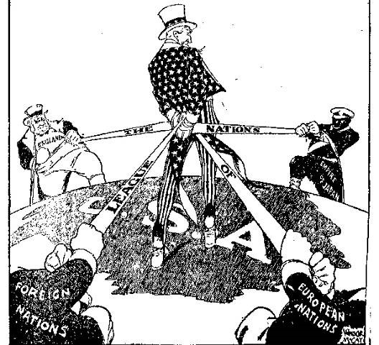
League of Nations
During the postwar treaty negotiations, Wilson worked hard to get as many of his Fourteen Points as possible included in the treaty. The Fourteenth Point, which proposed a League of Nations, was one that President Wilson was particularly committed to securing for world peace. After much negotiation, the League of Nations was included in the final provisions of the Treaty of Versailles. The treaty drafted at Versailles had to be ratified by the United States Senate as the final step for implementation in the United States.
Although Wilson believed strongly in the League of Nations, there was significant opposition to the concept among many Americans. Public opposition to the League of Nations ultimately led the Senate to vote against ratification of the treaty. Isolationists in the Senate believed that by joining the League of Nations, the United States would be obligated to get involved in future European conflicts.

