Unit 4: Creating a Nation Guided Reading Packet
SSUSH6 Analyze the challenges faced by the first five presidents and how they were resolved.
a. Examine the presidency of Washington, including the precedents he set.
Presidency of George Washington
George Washington, the most influential and popular figure of the time, was elected the first President of the United States. There was no clear understanding of how the office of the president would operate. The Constitution created the office, but there was not really a guideline for conducting the executive branch of the government. George Washington was challenged to chart the course for himself and future presidents. He often remarked, “I walk on untrodden ground.” During his two terms in office, George Washington set many precedents for the position that remain accepted procedure. Washington’s leadership and understanding of the critical role he played in shaping the future of the United States created the foundation for success in the new republic.
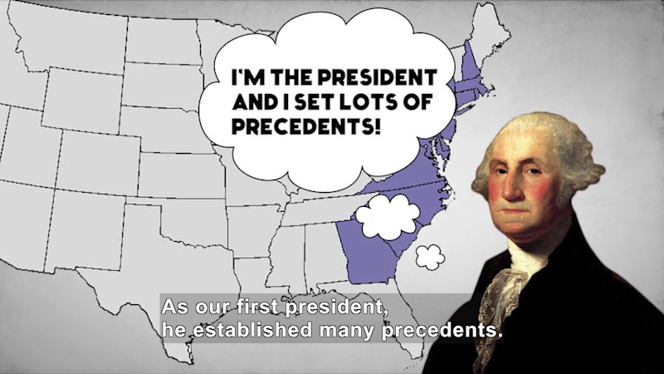
A precedent is an action that sets a basis for similar situations as they arise in the future. George Washington established important patterns, or precedents, for future presidents to follow. Some of the critical precedents Washington established for the presidency include forming a cabinet, using the modest title of “Mr. President,” establishing the constitutional authority to enforce laws, and retiring after two terms in office. One key development associated with Washington was the creation of the cabinet system. Washington called on Thomas Jefferson to be his Secretary of State and Alexander Hamilton to be his Secretary of the Treasury. For all of the new president’s experience in leading the military and participating in the various Continental Congresses and Constitutional Convention, Washington understood that others might have more expertise in some critical areas related to government policy. As a result, Washington created the cabinet system to surround himself with experts in various fields in order to better craft critical decisions in the best interest of the country. The appointment of Jefferson to Secretary of State is a prime example of this approach. Thomas Jefferson had spent the majority of the Revolutionary War period in Europe negotiating with world leaders for an alliance to help the Patriot cause. He was fluent in speaking and/or reading six different languages. Washington was a great military leader but did not possess Jefferson’s international experience. Some leaders might have felt threatened by giving positions of authority to other highly acclaimed individuals. Washington, however, understood the importance of making the best possible decisions for the new United States, and viewed the other leaders of his cabinet as an asset and not a threat to his own power.
The cabinet is a precedent that has been maintained even through today’s modern presidencies. Today, the President’s cabinet is traditionally made up of the Vice President and the heads of the fifteen different executive departments. There may be other key advisors to the President who function in a cabinet role. During George Washington’s presidency, the cabinet was made up of four individuals. Washington’s cabinet members did not always agree on the advice being given to the president. Heated arguments erupted between Hamilton and Jefferson in cabinet meetings over the expanding power of the federal government and what side the United States should take in the war that erupted between France and Great Britain. The challenging debates within Washington’s private cabinet meetings helped him to formulate the policy direction for issues critical to the development of the United States. Not all precedents set by Washington were as policy driven as establishing the cabinet.
The proper title for addressing the new President of the United States was not established by the Constitution. Much discussion and debate centered on this seemingly trivial issue. Some believed the office needed to project a proper level of reverence and dignity. Others, including George Washington, believed a more simplistic title reflected the true republican nature of the new government. There was great care taken to distinguish the office of President from resembling anything similar to a monarchy. George Washington emphasized this standard when the precedent was set during his term of office for addressing the chief executive as simply, “Mr. President.” There would be no lofty title of “majesty” or “excellency” or “exalted.”
During the early years of George Washington’s presidency, considerable tension existed between the United States, France, and Great Britain. The two European powers were once again at war and George Washington favored non-intervention to avoid siding with France against Great Britain. The United States persuaded Britain to forgive many pre-Revolutionary debts and to drop certain restrictions on US trade to the colonies Britain still held in the Americas. This ushered in an era of booming trade with Britain. Washington’s new government encouraged Congress to pass taxes on liquor to help pay the states’ debt from the Revolutionary War. The tax hit the small whiskey-makers in western settlements particularly hard because they made liquor using excess crops of grain in order to make it easier to transport. They even used whiskey as a medium of exchange. The Whiskey Rebellion resulted in Western Pennsylvania when armed violence broke out as farmers frightened and attacked federal tax collectors. George Washington led a large militia force into the western counties and put down the rebellion. Washington’s response set a critical precedent for presidential authority to enforce the law.
An important precedent George Washington set at the end of his second term as President of the United States was to not seek a third term. There is no provision in the original Constitution limiting a President to two terms in office. It was not until the 22nd Amendment to the Constitution was ratified in 1951 that the President became strictly limited to two terms as chief executive. The precedent Washington set for this voluntary limit was followed by every president until Franklin Roosevelt was elected four times in the 1930s-1940s.
George Washington, as President of the United States, was very popular among all classes of people in all regions of the country. This popularity would have likely given him another victory in the election of 1796 – if he had sought the office. Instead of running for a third term, Washington chose to step away from national politics and retire to his home at Mount Vernon in Virginia. His reasoning included a personal desire for retirement. He also wanted to demonstrate to the world that the transfer of power could be achieved peacefully under the United States’ new form of government. George Washington wanted to emphasize that he was not a king and that the republican system was effective. The voluntary two term precedent set by Washington lasted for many years.
There were a few other important precedents and policy perspectives George Washington felt very strongly about that did not survive beyond his administration. Washington was very concerned about emerging political factions in the United States during the early years of the republic. He also strongly opposed tying the United States to other countries through formal alliances. Both of these issues were addressed by Washington in his famous Farewell Address to the nation as he was leaving office in 1796 in which he emphasized three key points: First, Washington expressed his view that the United States should stay neutral and avoid permanent alliances with other nations. Second, he believed that good government is based on religion and morality. Third, he spoke about the dangers of forming political parties. He warned that political parties would cause people to work for their special interests rather than for the public good. Despite Washington's warnings, opposing political parties did indeed form.
Political parties had their origin in the differences of opinion between Washington’s Secretary of State, Thomas Jefferson, and Secretary of Treasury, Alexander Hamilton. Both felt very differently about the organization of the new nation and how the nation should be run, including the constitutionality of a national bank. Hamilton and his political supporters later became known as Federalists. They wanted to expand the power of the government to stabilize the nation and its economy. Jefferson’s supporters came to be known as the Democratic-Republicans and believed that the national government must limit its power to only those areas described by the Constitution. Within the foundations of these two groups is the two-party system that began to control United States politics after Washington’s presidency. Washington’s warning against parties was not heeded and when his retirement was announced, Hamilton, Jefferson, and their supporters attacked one another and competed to replace him.
George Washington’s presidency was challenging in that he was creating the office of the chief executive while he governed. The leadership demonstrated by the first President led to his popularity that spanned the nation and crossed the political divisions that were beginning to emerge. George Washington was a leader who understood the importance of the precedents he was setting in order that the new republic endure. The voluntary retirement of George Washington after two terms as President was a sharp contrast to the traditional monarchical rule common in Europe. The establishment of this peaceful transfer of power is an enduring precedent among the many that George Washington set as the United States’ first chief executive.

Document Analysis 1
“The [whiskey] rebellion has long been interpreted as a milestone in the creation of federal authority, and in most respects that is its chief significance. Certainly to the Federalists, who had long been striving for a strong national government, it was a major test: the new government successfully crushed organized and violent resistance to the laws. As Hamilton put it, the rebellion “will do us a great deal of good and add to the solidity [stability] of everything in this country...”
Source: Richard H. Kohn, “The Washington Administration’s Decision to Crush the Whiskey Rebellion,” The Journal of American History, December 1972
b. Explain the presidency of John Adams including the Sedition Acts and the influence on the election of 1800.
Presidency of John Adams
The election of 1796 was a bitter contest between John Adams, a Federalist, and Thomas Jefferson, a Democratic-Republican. The political parties George Washington had warned against were driving the election to determine his successor. Adams won by only a 71-68 margin in the Electoral College. George Washington’s elections in 1789 and 1792 were both unanimous. Under the provisions of the Constitution as it was originally written, the candidate who received the highest number of votes (over 50%) in the Electoral College would be the President and the candidate with the second highest number of votes would serve as the Vice President. This format quickly presented problems in the 1796 election. The Federalist John Adams became the President and the leading Democratic-Republican, Thomas Jefferson, became the Vice President. The difficulties presented by this arrangement became apparent very quickly. Adams’ victory by such a close vote indicates the division that had emerged between the political ideologies of the Federalists and Democratic-Republicans. Adams only served one term in office and he faced significant challenges during his presidency.
Entering the presidency, John Adams had already amassed an impressive record of government experience. He had supported the Patriot cause in Boston leading up to the Revolutionary War. He participated in the Continental Congress and was part of the Committee of Five tasked with drafting the Declaration of Independence. During the Revolutionary War, John Adams traveled Europe to help secure support for the new nation. He also helped to negotiate the Treaty of Paris in 1783 that ended the war and remained in Europe to help secure trade deals for the United States. After the new Constitution was ratified, John Adams was elected to serve as the country’s first Vice President under George Washington. Given this vast political and international experience, Adams was well-qualified for his new position as President of the United States.
Like Washington, John Adams set precedents that influenced future presidents as well as the course of American history. However, his administration was plagued by conflicts with France and Great Britain that crippled the nation’s economy. The financial difficulties and international conflict led Democratic-Republicans, including Vice President Thomas Jefferson, to vehemently criticize John Adams.
To subdue the Democratic-Republican opposition, the Federalist controlled Congress and Federalist President passed the Alien and Sedition Acts. These laws increased citizenship requirements so that Jefferson, and the Democratic-Republicans, could not receive support from the immigrant community. The citizenship requirement for the naturalization process was extended from five to fourteen years. The law also attempted to stop any criticism of the Federalists by limiting free speech and press rights. The “Alien” provision of the policy gave the executive branch the power to deport any immigrant aliens subjectively deemed as dangerous. The “Sedition” policy made it a crime for United States citizens to conspire against legal measures passed by the government, interfere with the business of government officials, or to promote insurrection. Of greater impact was the provision in the law that made it a crime to write, publish, or speak anything of “a false, scandalous and malicious nature” about the government or elected officials. Democratic-Republicans, with their propaganda filled newspapers and pamphlets, were the target of these laws.
Election of 1800
The country's growing economic problems, increasing taxes, and unpopular Alien and Sedition Acts hurt John Adams' chances of re-election in 1800. The results of the Election of 1800 gave power in the executive and legislative branches to the Democratic-Republican Party. There was, however, a snag in the Electoral College process. Thomas Jefferson tied with the other Democratic-Republican candidate, Aaron Burr. The House of Representatives broke the tie and voted for Jefferson instead of Burr.
The Election of 1800 was largely based on the differing political ideologies of the two parties. John Adams had lost the support of many Americans with the Alien and Sedition Acts, which the Democratic-Republicans portrayed as a threat to civil liberties. As more people began to support Thomas Jefferson's party and the Federalists began to fracture from within, the Election of 1800 transferred the federal government's power from one party to another. The nation transitioned from the Federalist's more centralized government approach to a more de-centralized government under the Democratic-Republicans, with the states having more power. The question, however, was whether Thomas Jefferson would be able to shift power back to the states and the American people once he took office. John Adams' one term as president was challenging. In addition to following the highly revered George Washington, he was faced with mounting opposition from the Democratic-Republicans. Adams' approach to controlling his rivals through the Alien and Sedition Acts cost him even more support as some Americans feared their individual rights were being restricted.
Document Analysis 2
“They have brought into the lower House (of Representatives) a sedition bill, which, among other enormities, undertakes to make printing of certain matters criminal, though one of the amendments to the Constitution has so expressly taken religion, printing presses, & out of the coercion (ability to limit them). Indeed this bill, and the alien bill are both so palpably (obviously) in the teeth of the Constitution as to show they mean to pay no respect to it (the Constitution).”
Source: Thomas Jefferson, from Jefferson Cyclopedia
c. Explore Jefferson’s expansion of presidential power including the purchase and exploration of the Louisiana Territory.
Presidency of Thomas Jefferson
Thomas Jefferson led the nation's Democratic-Republican Party and was a vocal critic of the Federalists' push for a stronger central government at the expense of the states. Once Jefferson was elected President in the contentious election of 1800, he was responsible for defending and leading the nation toward prosperity. Although his political philosophy leaned toward a de-centralized federal government, he actually expanded the power of the presidency during his two terms in office.
Jefferson was the first President to take the oath of office in the new national capital in Washington, DC. He tried to set a simplistic tone for his presidency by having a more informal inauguration without much fanfare. Jefferson did highlight the need for the country’s political divisions to heal and for both political parties to move forward. A famous line from Jefferson’s first inaugural speech is, “We are all Republicans – we are all Federalists.” Jefferson served two terms as President of the United States, during which he dealt with many domestic and foreign policy issues.
An area of conflict between the Federalists and the Democratic-Republicans was how to appropriately interpret the Constitution. Democratic-Republicans, like Thomas Jefferson, believed in strict construction of the Constitution. Supporters of strict construction believe that the Constitution must be interpreted by the literal content of the document. Only powers explicitly listed in the Constitution are allowed to be claimed by the federal government. This narrow interpretation of the Constitution restricts the power of the federal government and preserves more power for the states. In contrast, Federalists supported loose construction of the Constitution. This approach to constitutional interpretation claims that there are implied powers granted to the federal government in the Constitution. These powers may not be explicitly listed but are still granted to the federal government through the “elastic clause” in Article 1 of the Constitution. The clause grants Congress the power to pass all laws which shall be “necessary and proper” for carrying out the business of the government. Federalists argued that this vague wording purposely left implied powers to the government in the event of unforeseen circumstances. The Democratic-Republicans opposed such unrestricted power. While Jefferson ideologically was a strong advocate of strict construction, his actions as president, in some ways, practiced loose construction.
The purchase of the Louisiana territory from France is an example of Thomas Jefferson’s expansion of presidential power through loose construction- even though he claimed to be a strict constructionist. Louisiana was originally a part of New France. However, the region had been subject to much transition and had changed hands several times. At the time of Jefferson’s election, Louisiana was ruled by Spain but was home to many American merchants and farmers. In 1800, the territory changed hands again when the French general, Napoleon Bonaparte, retrieved Louisiana from Spain. New Orleans was the key port in the region and was an important outlet of American farm goods produced in the Ohio River Valley. President Jefferson sent Robert Livingston and James Monroe to France to inquire about the purchase of New Orleans for the United States in order to secure a permanent port on the Mississippi River. Napoleon, seeing an opportunity to finance his ongoing conflicts in Europe and a way to keep the British from expanding in North America, agreed to sell the entire region, not just the port at New Orleans, to the United States for $15 million. Livingston and Monroe had been prepared to pay up to $10 million for just New Orleans. The Louisiana Purchase doubled the size of the United States. Through this deal, lands critical for future expansion were acquired and the United States had secured the port at New Orleans to export American goods abroad.
Nowhere in the Constitution is the President given the power to purchase land from another country. Jefferson entered the presidency as a strict constructionist, but his purchase of Louisiana was an action beyond the provisions of the Constitution. The Louisiana Purchase is an example of how Thomas Jefferson expanded the power of the presidency as the Constitution makes no provision for this type of presidential action.
With the acquisition of approximately 875,000 square miles of new land, gathering information about the region and the opportunities it might offer to Americans was important to Thomas Jefferson. More settlers were moving to the Ohio River Valley in the Northwest Territory by 1800. Jefferson had sensed that the destiny of the nation was tied to the Mississippi River Valley. Jefferson worried that as more people moved to these isolated areas, the challenges of communicating and trading with the east coast could prompt the areas in the west to secede from the United States.
No one was exactly sure what lay between St. Louis and the Pacific Ocean. Jefferson sent Meriwether Lewis and William Clark on a government-funded exploration of Louisiana and the western lands all the way to the Pacific Ocean. On their 16-month journey, Lewis and Clark charted the trails west, mapped rivers and mountain ranges, wrote descriptions and collected samples of unfamiliar animals and plants, and recorded facts and figures about the various American Indian tribes and customs west of the Mississippi River. Most significantly, Lewis and Clark reached the Pacific Ocean and established a legal claim to the Oregon territory along the Columbia River. This claim allowed for the future expansion of the United States to the Pacific Ocean. The Lewis and Clark expedition and subsequent claim to the Oregon territory were not presidential powers listed in the Constitution. This is another example of the strict constructionist President’s actions falling in line with the loose constructionist ideology.
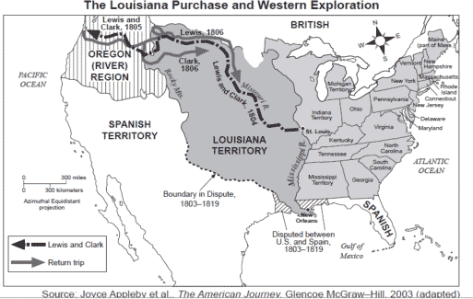
Document Analysis 3

Jefferson was also faced with mounting international pressure as France and Great Britain were once again at war. American ships and sailors were being harassed by both warring nations as the US sought to boost trade with Europe. The issue of the impressment of US merchant sailors weighed heavily on Jefferson who wanted to avoid war. His implementation of an embargo was an attempt to put economic pressure on the British in order to force them to not interfere with American ships or sailors

d. Explain James Madison’s presidency in relation to the War of 1812 and the war’s significance on the development of a national identity.
Presidency of James Madison
James Madison had many roles in the development of the United States. He was the principal author of the United States Constitution and contributed essays to the Federalist Papers supporting ratification. Madison also served as Thomas Jefferson’s Secretary of State. When Madison was elected, foreign policy and the mounting tension with Great Britain were critical issues that required his attention. The challenge he faced was how to avoid another costly war with Great Britain but still increase the United States’ economic growth through international trade.
Britain and France had been at war since 1789. Americans were often caught in the middle as British and French naval forces seized American ships and crews. Earlier Presidents were able to steer a middle course and avoid a declared war in Europe by using diplomacy and attempting embargos. However, renewed warfare in 1809 intensified tensions between the British and the United States. On June 12, 1812, President Madison asked for a war declaration from Congress. The War of 1812 officially began.
Madison cited four reasons for the United States’ declaration of war against Great Britain. First, Americans objected to restrictions Britain was enforcing to prevent neutral American merchants from trading with the French. Second, Americans were outraged by the British policy of impressment. Under this policy, thousands of American sailors were forced against their will to serve in the British navy after their merchant ships were captured at sea. Third, the British refused to turn over fortifications along the Great Lakes as required by the 1783 Treaty of Paris. Americans suspected the British were using these British-held sites to give support to American Indians as they continued to fight to keep Americans from settling lands west of the Appalachian Mountains. The fourth reason Madison gave for declaring war was that Americans wished to drive the British out of North America altogether by conquering Canada while the British army was fighting the French in Europe.
The war declaration came at a time when the young United States was not financially or militarily prepared to fight. The Democratic-Republicans had scaled back the federal government and its budget, which meant the military had also been reduced during the Jefferson administration. At the time of the war declaration in 1812, the United States army was made up of only about 3,000 soldiers who were not equipped or trained to fight effectively in battle. The American navy was in a little better condition than the army and had some small initial successes at the beginning of the War of 1812.
There were essentially three fronts to the war, which lasted until early 1815. There was a naval conflict in the Atlantic and Chesapeake Bay off the coast of Virginia. Another important theater of war was on the United States’ northern border with Canada. The final area of fighting was in the south and ended with the Battle of New Orleans. Although there were very few military successes throughout the course of the war, the United States did not lose any territory to the British and America’s army and navy gained respect because they had stood up to Europe’s most powerful nation. The outcome of the War of 1812 also ended all hopes American Indians had of driving the Americans out of the Ohio Valley.
There were two notable victories for the American forces. The Battle at Fort McHenry in Baltimore was the subject of Francis Scott Key’s poem, the Star Spangled Banner, which was later set to music and became the national anthem. The most decisive American victory in the War of 1812 actually came after the Treaty of Ghent had been signed to end the war. The delayed communication across the Atlantic Ocean meant that no one in North America knew that the war was over. The Treaty of Ghent was signed on December 24, 1814 and the Battle of New Orleans began on January 8, 1815. General Andrew Jackson led the American forces. The battle was an overwhelming victory for the United States and made General Jackson a national hero. The British suffered a devastating casualty count of over 2,400 compared to American casualties of approximately 300. The victory in the Battle of New Orleans created the illusion that the United States won the War of 1812 outright even though the conflict actually ended with a negotiated settlement prior to General Jackson's great success on the battlefield.
Some long-term effects of the War of 1812 include a change in the political dynamics of the United States and the emergence of a new national identity. Politically, the war marked the end of the Federalist Party because they had failed to support the call to a popular war. The Federalists were highly concerned that war with Great Britain would be unwise because of the danger it would pose to United States’ trade exports. Instead of hurting the economy, the war served to stimulate America’s economic growth. Due to the British blockade of America’s coast, manufacturing began to quickly develop in the United States. The war also ended any further military hostility between the United States and Great Britain.
A new American identity also developed as a result of the War of 1812. Americans had fought the British twice and were still an independent nation. A belief began to emerge in North America, as well as Europe, that the United States was not an experiment in self-government that would eventually be subsumed by Britain or some other European power. Instead, the United States was a nation that had transitioned from a young and vulnerable situation to one of strength and viability. While the Treaty of Ghent was a negotiated settlement and not truly a victory for the United States, the War of 1812 still boosted the confidence of Americans and set the stage for significant territorial and economic growth. James Madison faced the challenge of war with Britain and emerged with bright prospects for the future.
Perhaps most importantly, the War of 1812 helped produce a stronger sense of nationalism (pride in one’s country) among U.S. citizens. People felt a great deal of pride after standing up to the mighty British again. As a result, U.S. manufacturing and agriculture improved and grew prosperous. Northern manufacturers sold more and more of their products to other regions of the country, while the South's plantation economy exploded as the nation's only major supplier of cotton. By the time the war ended, U.S. citizens had a new sense of national pride and both U.S. manufacturers and planters had established themselves as respectable players in domestic and international trade.
e. Explain James Monroe’s presidency in relation to the Monroe Doctrine.
Presidency of James Monroe Document Analysis 4
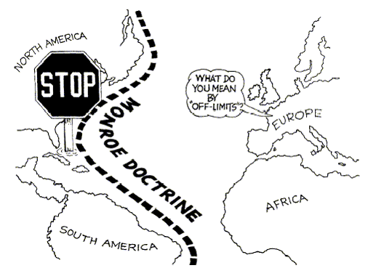
James Monroe had served as James Madison's Secretary of State and easily won the Presidential Election of 1816. The old Federalist vs Democratic-Republican rivalry had dwindled after the War of 1812. There was great unification among a majority of Americans around the Democratic-Republicans and the nation was prospering economically. Thus, the period is often referred to as the Era of Good Feelings. During James Monroe's presidency, the United States' foreign policy approach was clearly defined and remained the guide for future presidents over the course of many decades.
Following the end of the Napoleonic Wars, Spain's colonial holdings gained their independence. When a possible Franco-Spanish alliance appeared imminent in 1823, President James Monroe warned the nations of Europe not to meddle in the politics of North and South America. When a group of European countries planned to help one another capture colonies in the western hemisphere that had recently gained independence, Monroe announced that the United States would prevent European nations from interfering with independent American countries. This became known as the Monroe Doctrine. Further, Monroe said the United States would remain neutral in wars between European nations and would not interfere in their American colonies. In summary, the Monroe Doctrine defined a key aspect of United States foreign policy.

SSUSH7 Investigate political, economic, and social developments during the Age of Jackson.
a. Explain Jacksonian Democracy including expanding suffrage, the Nullification Crisis and states’ rights, and the Indian Removal Act.
Presidency of Andrew Jackson
Andrew Jackson emerged from the War of 1812 as a very popular war hero. He soon entered the political arena and questioned the existing framework for democracy. Jackson challenged the Democratic-Republicans and their expanding power. He believed that the party’s original mission to restrict the power of the federal government and preserve the rights of states and individuals was being lost in the country’s growth. Instead of supporting individuals, states, and agricultural pursuits, Jackson believed the Democratic-Republicans were becoming more centered on industrial progress, expanding federal power, and the upper-class. The aggressive challenge Jackson lodged against the Democratic-Republicans ended the Era of Good Feelings’ national unity and returned the country to a two-party system.
Jacksonian Democracy- Universal Suffrage and Nullification Crisis
Jackson and his supporters shared a political philosophy later referred to as Jacksonian Democracy. It sought a stronger presidency and executive branch, and a weaker Congress. Out of respect for the common man, it also sought to broaden public participation in government, so it expanded voting rights to include all adult white males, not just landowners. The implementation of universal male suffrage by state legislatures dramatically increased the number of voters in the United States. The number of voters in the presidential election of 1824 was approximately 350,000. With the push by Jackson and his supporters for the expansion of voter eligibility, 2.4 million Americans participated in the 1840 presidential election. Most of the new voters were from the lower classes, which had previously been restricted from voting due to property requirements. These common men tended to support Andrew Jackson and their movement coalesced into a new political party – the Democratic Party. The old Democratic-Republican Party also transitioned at about the same time into the Whig Party. The Whig Party tended to favor industrial expansion and was supported primarily by the upper-classes. The United States was once again divided between to strong political parties with very different perspectives and goals for governing.
Another principle of Jacksonian Democracy was that politicians should be allowed to appoint their followers to government jobs as a way of limiting the power of elite groups. This process became known as the spoils system. Jackson believed that the President had to make sure the executive branch employees were carrying out the business of the government according to the plans of the party in power. Therefore, he believed these government jobs, of necessity, should be held only by people who had demonstrated their loyalty to the party by working in campaigns. The new spoils system he implemented sometimes led to corruption and unqualified workers in government positions.
Jacksonian Democracy also favored limiting the power of the federal government in favor of expanded state power. This issue of states’ rights was a very divisive issue during the early 19th century. The idea of states’ rights revolved around who held the supreme power of government – states or the federal government. The root of the argument became fixed in the Constitutional debates between the Federalists and the Anti-Federalists during the ratification process. The issue re-emerged in 1798 with the passage of the Kentucky and Virginia Resolutions, which opposed the legality of the Alien and Sedition Acts.
The issue of whether states could nullify federal law nearly split the United States. Congress had passed the Tariffs of 1828 and 1832 to protect American manufacturers from competition with cheap British imported goods. Southerners believed that the tariff was purposely passed to hurt southern plantation owners and would only benefit northern industrialists. In response, South Carolina legislators nullified the tariff. Andrew Jackson’s Vice President, John C. Calhoun, argued with the President about the right of states to nullify (cancel) federal laws they opposed. Calhoun, a South Carolinian, resigned from the vice presidency to lead the efforts of the southern states in the crisis. He even went so far as to suggest South Carolina’s secession from the Union. Calhoun’s loyalty to the interests of the southern region/section of the United States, rather than to the United States as a whole, made clear how divided the nation had become. The Nullification Crisis was resolved when a compromise tariff was passed and Jackson’s Congressional supporters authorized the President to use the army and navy to enforce federal law. South Carolina then backed down from its secessionist threats. The Jacksonian Democracy that purported to uphold states’ rights placed a limit on the approach when it threatened the Union as a whole. The Nullification Crisis had a profound effect on North-South relations. Calhoun continued to vocally support the issue of states’ rights and began to build a coalition of southerners who would not back down from the threat of force in the future. Slave owners began to wonder what would happen if the Federal government decided to end slavery by law.
Jacksonian Democracy- Indian Removal Act Document Analysis 5
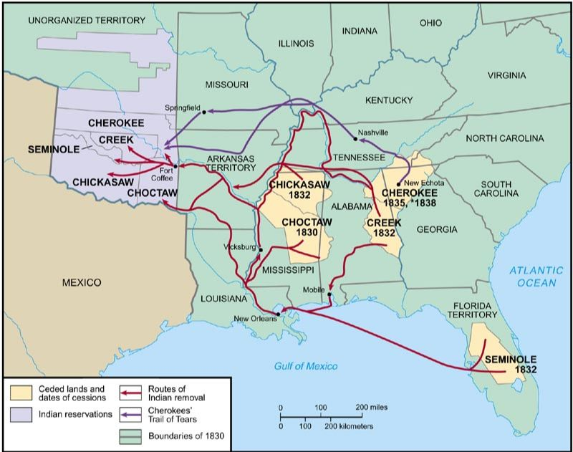
Andrew Jackson’s democratic philosophy and appeal to the common man did not encompass American Indians. During his military career, Jackson was a known for his attacks on the Seminole and Creek tribes in the southern United States and northern Florida during the War of 1812. Once Jackson was elected President, he worked to expand the land available for white settlement. To achieve this, Jackson signed the Indian Removal Act in 1830, which forced thousands of American Indians to leave their homelands and re-settle west of the Mississippi River. The American Indians would be given land in the west in exchange for the lands they held in the east.
While most tribes resented the policy, they reluctantly complied. However, a few tribes, such as the Cherokee Nation in Georgia, refused to give up their land to the state. Georgia had passed a statute that abolished the Cherokee government and laws in the eyes of the state. The state was planning to use this provision to take control of Cherokee lands that had been granted to them by a 1791 treaty with the United States government. The issue in Georgia was highly charged since gold had been discovered in the northern part of the state. The Georgia lands where white settlers flocked in the gold rush of the 1830s was mostly held by Cherokee Indians. The Cherokee filed suit to challenge the loss of their land. The case was heard by the United States Supreme Court and Chief Justice John Marshall issued the ruling for Worcester v. Georgia. In this 1832 decision, Marshall sided with the Cherokee Indians and said that the state of Georgia had no authority to legislate against the tribe.
After the Supreme Court issued the ruling, President Andrew Jackson openly challenged John Marshall and the decision. Jackson stated, “John Marshall has made his decision; now let him enforce it!” In 1835, the Georgia Cherokee reluctantly surrendered their lands. Over the next few years, the Cherokee’s were forced to travel to the west over what became known as the Trail of Tears. The forced removal was difficult and thousands of American Indians died along the way due to starvation, disease, and exhaustion.
Jacksonian Democracy is a term that refers to more than the eight years Andrew Jackson served as President. It is more of a general term that encompasses the formation of the Democratic Party, the Jackson Presidency, and also the broad political reforms that extended political participation to the common man over the course of the 1830s through the 1850s. Not all groups were included in the Jacksonian Democracy movement. Although universal male suffrage was achieved through the promotion of Jacksonian Democracy, American Indians, enslaved and free Blacks, and women did not benefit from the egalitarian values the term suggests.
b. Explain how the North, South, and West were linked through industrial and economic expansion; including Henry Clay and the American System.
Henry Clay and the American System
Industrialization expanded in the United States following the War of 1812 and really picked up momentum in the 1830s. The emphasis on building American manufactures was one of the points of conflict between the Whig Party, led by Henry Clay, and the Jacksonian Democrats. Clay and the Whigs believed very strongly that the federal government should be involved in funding progress through infrastructure projects and investing in the development of industry. As industrialization expanded, each region of the United States was impacted. The North, South, and West were increasingly linked together through advances in transportation and the industrial process.
The era known as the Industrial Revolution began in Great Britain in the 18th century when the country began the transformation from purely agrarian to a modern industrial and commercial economy. Soon hand-made and home-made goods were replaced by machine made and factory made goods and power driven machines operated by semi-skilled or unskilled workers. The Industrial Revolution made its way to the United States in 1793 with the completion of Samuel Slater's water powered textile mill in Rhode Island. Real impetus for the change to an industrialized economy came in the first decade of the 19th century as the Napoleonic Wars interfered with America's exports to European markets and its imports from Great Britain. Americans sought ways to improve the national economy.
As in England, the success of the Industrial Revolution was aided by four factors. First, transportation was expanded. Second, a power source was effectively harnessed (water power and, shortly thereafter, steam power). Third, improvements were made to industrial processes to accelerate production. Lastly, the government helped protect fledgling American manufactures by passing protective tariffs. Henry Clay and the Whigs supported the idea of economic nationalism in which the federal government would support these factors in developing a robust industrial network in the United States. The approach sought to boost the nation's overall economic success rather than each region of the country operating somewhat independently of the others. The nation had abundant resources available in the south, the ability to harness waterpower from swift rivers to operate factories in the north, a growing immigrant population to labor in the factories, and new methods of transportation to connect the farms, factories, and markets across all regions.
Connecting the vast distances between raw material cultivation, factory, and market was a challenge that had to be overcome if industrial and economic expansion was to develop. Private companies had been building the young nation's roads since the 1790s. These roads were often turnpikes, or toll roads, which travelers paid a fee to use. In turn, these fees were used to pay for upkeep of the new roads. When roads could not be built, barges were used on rivers to carry people and goods - as long as the rivers flowed in the same direction that settlers and merchants wanted to travel. Soon a new invention, the steamboat, enabled people to buy tickets from private companies that operated the boats to travel upstream as easily as downstream. In the wilderness, where rivers did not run and roads could not be built, government leaders joined businesspeople to build canals - artificial rivers. These shallow waterways were for barges, not steamboats, and had pathways alongside on which horses or mules pulled the barges.
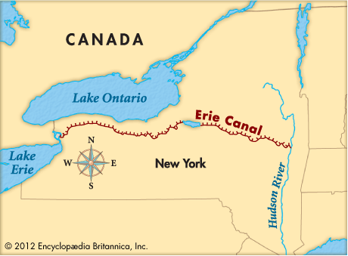
The most famous canal built in this era was the Erie Canal, which stretches 363 miles and connects the Great Lakes to the Atlantic Ocean. It opened in 1825 after eight years of construction. The Erie Canal served as a turnpike for large cargo carrying barges where a road could not be easily built. Transportation costs for goods were lowered because of the canal's more efficient transportation. This not only opened up western New York and regions further west to increased settlement, but also helped unite new regions with the Atlantic states. The effect of the Erie Canal on this country was stunning. Cargo that cost $100 per ton and took two weeks to haul by road could be moved on the Erie Canal at $10 per ton in three and a half days.
By the 1830s, an even more rapid mode of transportation was set to further expand commercial production and the economy. Railroads were less costly, time consuming, and labor intensive to build than canals. By 1850, there were 9,000 miles of railroad track crossing the United States and further cut transportation time. The result of transportation advancements was a more interconnected nation that could more efficiently industrialize and grow a national economy.
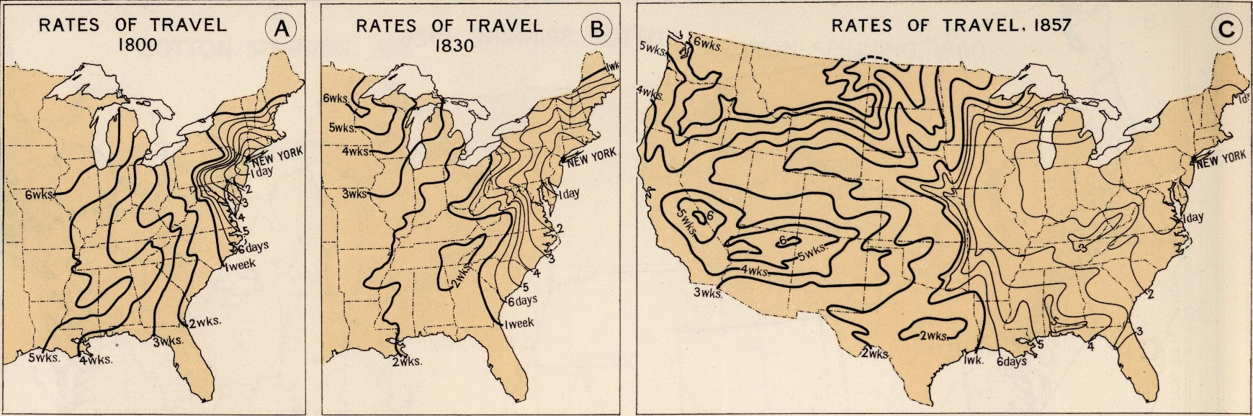
Document Analysis 6

With improved transportation methods rapidly changing the United States, Henry Clay became more involved in promoting the nation's economic growth. Clay was a Kentucky politician, founder of the Whig Party, and rival of Andrew Jackson. He supported industrialization and believed that the federal government needed to take strong action to ensure the economic growth of the United States. The American System was Henry Clay's plan for expanding production in the United States.
There were three components to the American System. First, Clay encouraged the Congress to pass protective tariffs that would make imported goods more expensive than similar products manufactured in new American factories. The second key feature of American System was federal funding for internal improvements to the infrastructure of the United States. Rather than states or private businesses being the primary contractors for roads, canals, or railroads, the federal government would fund the large scale transportation projects that would connect far reaching points instead of being limited to state boundaries. The third component of the American System that Henry Clay believed was the key to the entire process for industrial and economic expansion was the reestablishment of a National Bank to issue a national currency and serve as a depository for federal funds. The first Bank of the United States was established during George Washington's presidency and was the creation of Alexander Hamilton. It had expired in 1811 while the Democratic-Republicans were in power. Whigs, such as Henry Clay, believed it was essential to bring back a National Bank in order to fund internal improvement projects, stabilize the economy, and support new industrial pursuits. The Jacksonian Democrats opposed the idea of a National Bank because they believed it supported the upper class industrialists at the expense of the small farmer.
The North, South, and West were physically linked through the improved transportation developments of the early 19th century. The regions were also linked through the expansion of industrial pursuits. Most factories were located in the North due to the swift flowing rivers that generated power and the large immigrant populations who supplied cheap, unskilled labor in the factories. The American South and West supplied the raw materials needed to manufacture finished products. Goods were transported by road, canal, or rail as a result of the widespread internal improvements to the infrastructure made by the state and the federal governments. Henry Clay was an immensely important figure in the progress of American industrialization and economic nationalism.
c. Explain the influence of the Second Great Awakening on social reform movements, including temperance, public education, and women’s efforts to gain suffrage.
Second Great Awakening
In the 1820s, a Second Great Awakening arose in the United States. The Jacksonian Democracy's emphasis on the common man bolstered the religious revival that swept the nation. Revivalist ministers preached sermons that appealed to all classes and spread a message of salvation for all. One of the effects of the Second Great Awakening was a desire by Christians to attack perceived social ills in 19th century America. Temperance, public education, and women's efforts to gain suffrage were all areas of reform that emerged from the religious focus of the period.
Public Education Movement
Public education was another area of reform that Second Great Awakening religious followers supported. Until the 1840s, there was little public education. Only the wealthy educated their children. Reformers believed that in order for democracy to be effective an educated population would be needed. Reformers wanted to teach civic responsibility and morality. Horace Mann of Massachusetts, along with Henry Bernard of Connecticut, began the Common School Movement. The Common School Movement hoped to create good citizens, unite society and prevent crime and poverty. Mann advocated a free public education, financed by local funds and administered by a local school board and superintendent. This model is essentially the one used in America today.

Temperance Movement Document Analysis 7
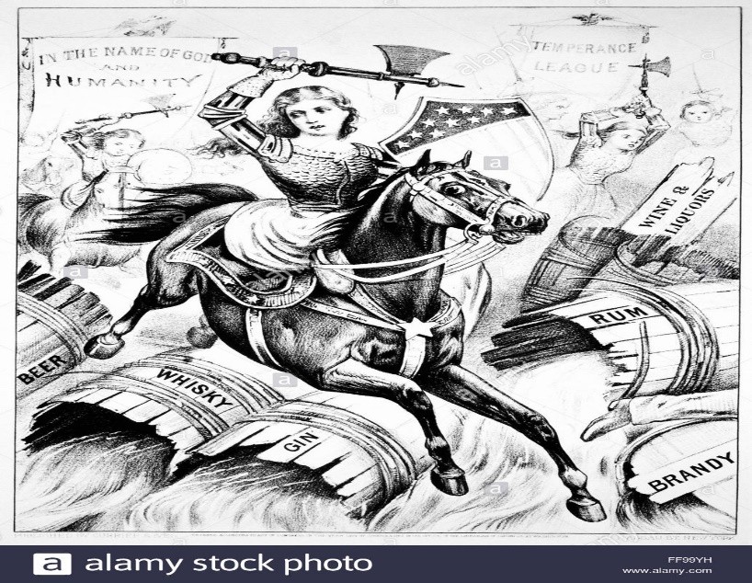
The stress of an industrial environment, poor quality water, and cheapness of liquor all contributed to an increase in alcohol consumption during the early 19th century. The temperance movement grew out of a desire to protect women and children from abuse and general poverty associated with the workingman spending his pay on drink. They used moral arguments to target the dangers of alcohol. The temperance movement originally attempted to get people to drink less (temper their drinking) but quickly moved to pledges of abstaining from drinking. In the beginning of the period there were many temperance societies, but around 1835 most merged into the American Temperance Society. The movement was successful in reducing the amount of alcohol consumed but fell short of gaining a total ban on drinking in the United States.
Women’s Rights Movement
As industrialization progressed in the United States, men and women were beginning to redefine their roles in the family and society. Some women from middle and upper class families had more leisure time, which allowed them to become more involved in the religious and reform movements of the period. Women in the early 1800s were legally and socially inferior to men. Women could not vote and, if married, could not own property or retain their own earnings. Women were leaders in the reform movements, such as the temperance and abolitionist movements. However, in the 1840s, a number of prominent women activists were denied access to the London World Anti-Slavery Convention because of their gender. These women, including Elizabeth Cady Stanton, Lucretia Mott, and the Grimke Sisters (Angelina and Sarah) became outspoken advocates for women's equality. With the advent of universal male suffrage, women began to hope that suffrage would be extended to them.
To push forward their ideas, Stanton and Mott organized a meeting "to discuss the social, civil, and religious condition and rights of woman." The conference was held in Seneca Falls, New York on July 19-20, 1848. The meeting was attended by 300 people- including 40 men. Curiously, none of the women felt that they should preside over the meeting, so Mott's husband initially led the conference. Stanton drafted the Declaration of Sentiments, modeling her work after the Declaration of Independence. Stanton's Declaration called for an end to the unequal treatment of women. Stanton drafted eleven other resolutions dealing with women's equality. Her ninth resolution, which called for women to have the right to vote, nearly failed. However, Frederick Douglass gave a speech, which persuaded the delegates to vote for the proposal. One hundred men and women signed the Declaration of Sentiments. The Seneca Falls Conference marked the beginning of the Women's Rights Movement.

d. Explain how the significance of slavery grew in American politics including slave rebellions and the rise of abolitionism.
Document Analysis 8
“As a Southerner, I feel that it is my duty to stand up here tonight and bear testimony against slavery. I have seen it! . . . I know it has horrors that can never be described. I was brought up under its wing. I witnessed for many years its demoralizing influences and its destructiveness to human happiness. I have never seen a happy slave.”

Source: This is a quote from Angelina Grimké (1805-1879), She gave this speech in Philadelphia, Pennsylvania in 1838

Rise of Abolitionism
The issue of slavery has been present in American politics since the nation’s inception. Slavery was an issue when Jefferson drafted the Declaration of Independence. The delegates to the Constitutional Convention created a series of compromises addressing slavery to placate Southerners at Philadelphia. Jefferson and Washington spoke out against slavery and freed their own slaves upon death. Both historical figures have been scrutinized for the contradiction of owning slaves while speaking out against the practice. Slavery was prohibited in the Northwest Territories by federal law so that slave holding was confined to those states south of the Mason-Dixon Line. Prior to the cotton gin, slavery was nearly dead in the Upper South, awaiting its final benediction by state legislatures, and was dying a slow death in the Lower South. The cotton gin and westward expansion revived slavery. Eli Whitney invented the cotton gin in 1793. It is a machine that rapidly removes cotton plant seeds from the valuable cotton fiber used to make thread and fabric. By producing more cotton in a day than any person could clean by hand, the gin reduced the cost of processing cotton and greatly raised the profit from growing it. To further cut costs and raise profits, unskilled slaves were often put to work running the cotton gins in southern states.
Politicians in the first third of the 1800s sought to maintain “a perfect equilibrium” on the issue of slavery in several ways. First, by maintaining an equal number of slave and free states. The second way to maintain peace was to prevent slavery from becoming a divisive issue through the passage of the “gag” rule, which prevented the discussion of slavery in the House of Representatives from 1836-1844. Third, division over slavery was minimized by continuing the process of working out compromises on the issue in the 1850s. However, as the mid-western and northern states continued to grow in economic power and population (political representation), slavery became increasingly entangled in every political issue facing the nation, such as nullification, states’ rights, and the admission of new territories as states.
Party politics were also affected by slavery. The two-party political system re-emerged in the early 1830s with the birth of the Whig Party. The party was short-lived as the issue of slavery fatally split the party by the end of the 1850s. New parties that were far more vocal on abolition, such as the Liberty Party and the Free-Soil Party, formed in the 1850s. These parties caused great fear among southerners who felt increasingly besieged, but by 1860 nearly all of these minor parties had self-destructed.
Abolition movements existed in America since the colonial period when the Quakers led the effort to end slavery. Their popularity waned after the American Revolution but were renewed in the 1830s as part of the Second Great Awakening reform movements. Three groups of abolitionists emerged during this period. One group, the American Colonization Society (1818) called for the emancipation and transportation of freed slaves back to Africa to be settled in the new colony of Liberia. The second group, the American Anti-Slavery Society (1833), was led by William Lloyd Garrison and called for immediate emancipation by any means necessary. A moderate group, the Liberty Party, pledged to end slavery through legal and political means.
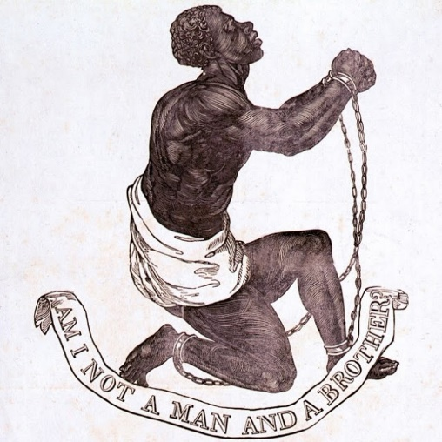
Some of the most notable abolitionists were William Lloyd Garrison, Frederick Douglass, and the Grimke Sisters. Garrison was the leading voice for many reform movements and abolition was a particularly important cause to him. He was the founder and editor of the Liberator newspaper, the leading abolitionist newspaper known for graphic stories of the bad treatment slaves endured. Frederick Douglass was a former slave who worked for Garrison in the abolitionist movement. Douglass traveled widely giving eloquent speeches and publishing his own autobiography and an antislavery newspaper – The North Star. Douglass is considered by many to be the most influential former slave or free Black in the abolitionist movement. Sarah and Angelina Grimke were white southern women who lectured publicly throughout the northern states about the evils of slavery they had witnessed growing up on a plantation.
The abolition campaign included both men and women; Northerners and some Southerners. For the first time, Blacks began to play a significant role in the movement. Instead of a gradualist approach, the new abolitionists advocated for immediate emancipation without compensation for slave owners. Abolition became a divisive issue as the southern states reacted against growing hostility in the North toward slavery.
Slave Rebellions
Slave rebellions also began to occur and caused slave owners to implement even more harsh restrictions on slaves. The Black preacher, Nat Turner, believed his mission on Earth was to free his people from slavery. Seeing an 1831 solar eclipse as a message from God, he led a slave rebellion on four Virginia plantations. Approximately 60 whites were killed before Turner and his followers were captured, tried, and executed. Fear and anger over the murder of primarily white women and children led to many innocent Blacks becoming victims of mob violence. Virginia, a state that had been considering a ban on slavery, instead passed a series of laws to strengthen the institution of slavery. Other southern states quickly passed laws that emulated Virginia’s revised slave codes to reflect more strict control.

Document Analysis 9
