Unit 3: The Constitution Guided Reading
SSUSH5 Investigate specific events and key ideas that brought about the adoption and implementation of the United States Constitution.
a. Examine the strengths of the Articles of Confederation including but not limited to the Land Ordinance of 1785, the Northwest Ordinance of 1787, and their influence on westward migration, slavery, public education, and the addition of new states.
Strengths of The Articles of Confederation
Following the adoption of the Declaration of Independence, the newly independent states were cautious about giving too much authority to a central (national or federal) government. They preferred a confederation, in which each state would maintain its sovereignty while being loosely unified as a nation. For this reason, Congress drafted the Articles of Confederation. The Articles of Confederation became the first national government in America. Two of the strengths of this new national government were the Land Ordinance of 1785 and the Northwest Ordinance in 1787.
The Articles of Confederation were successful in managing the new territories acquired through the 1783 Treaty of Paris that concluded the American Revolution. The region west of the Appalachians had been settled by French and English traders and was a strategic objective of both the French and Indian War and the American Revolution. The new United States came to possess the land and it was successfully administered under the Articles of Confederation system of government. Several states claimed portions of the region and reluctantly gave up claim to the lands in exchange for repudiation of their state Revolutionary War debts. Congress hoped to sell the public lands in the region to settle outstanding debt and to finance the operation of the new government. To rectify competing land claims, the Confederation Congress passed the Land Ordinance of 1785. The Land Ordinance of 1785 was significant in providing a mechanism for division of the land into six-square-mile rectangular townships. The townships were then subdivided into 36 sections, each measuring one-square-mile or 640 acres. The sections were sold at auction for $1 per acre, with a minimum sale being one section in size. Because the minimum sale price was $640, the primary buyers were land speculators who would then re-sell the land to settlers headed west for opportunity. An important stipulation of the law was that the revenue from the sale of the sixteenth section of land in each township would be reserved for the establishment of public schools. The sale of land through the system established in the Land Ordinance of 1785 was successful in generating revenue for the new United States government that was facing debt from fighting the Revolutionary War.
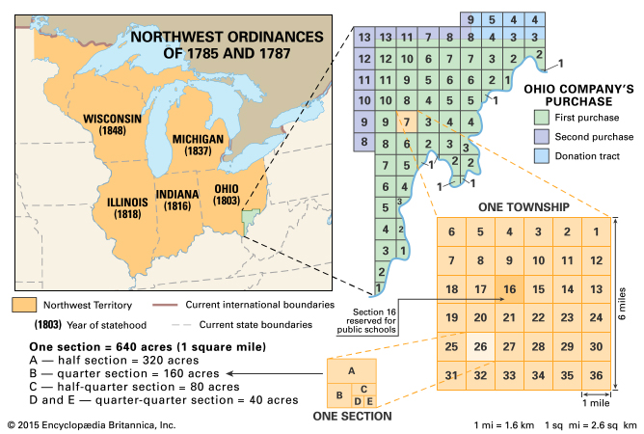
The land north and west of the Ohio River became the Northwest Territory. It was the first territory created outside the original thirteen states. In 1787 Congress passed the Northwest Ordinance. The law established the method by which new territories would be admitted to the United States. The ordinance banned slavery in the Northwest Territory effectively making the Ohio River the boundary between free and slave regions. The region was a lawless region prior to the passage of the 1787 Northwest Ordinance. To establish order in the territory just beginning to be settled, the federal Congress would appoint a governor, a secretary, and three judges to preside over the region. Becoming a full and equal state to the original thirteen was a progression of steps based on population increases. Once a territory reached a population of 5,000 free male adults, then it could elect its own local assembly. The next step toward joining the United States was to apply for full statehood once the population of the territory reached 60,000 free inhabitants. Ohio was the first state to enter the union under this system. The Northwest Ordinance of 1787 provided guidelines under which new states could be admitted to the union.
It eventually resulted in the formation of five states: Ohio, Indiana, Illinois, Michigan, and Wisconsin. It is important that US territories had a path to statehood rather than being permanently bound to a "colonial" arrangement with the original thirteen states. There was no special status designated for the original states under the arrangement of the Northwest Ordinance.
This law demonstrated to Americans that their new national government intended to encourage westward expansion. The laws of the nation would follow its citizens across the continent. New states would be admitted to the nation as equal members of the Union. The polices of the Land Ordinance of 1785 and the Northwest Ordinance of 1787 not only fostered westward expansion but also took steps to legislate for public education and to limit slavery in the newly added territories.
Benefits of the Northwest Ordinance
- Encouraged westward migration
- Banned slavery in new territories
- Made laws for admitting new states
- Mandated the establishment of public schools
b. Evaluate how weaknesses in the Articles of Confederation and Daniel Shays’ Rebellion led to a call for a stronger central government.
Document Analysis 1
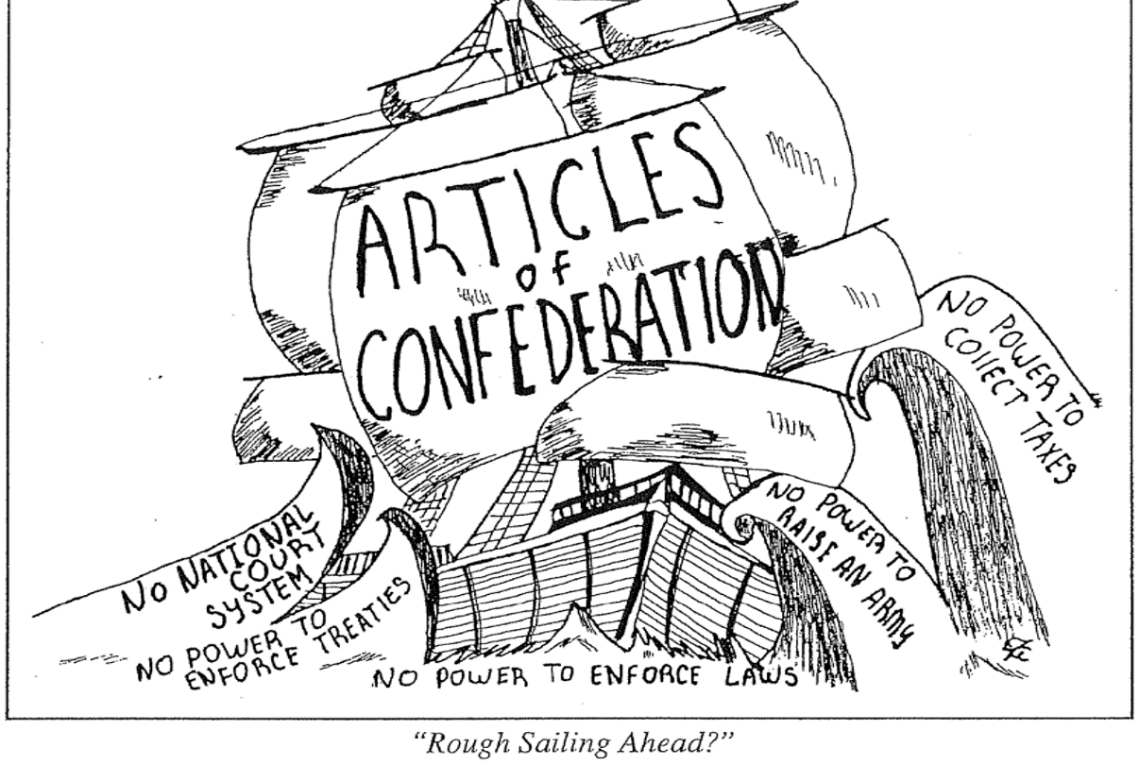
Weaknesses of the Articles of Confederation
The Articles of Confederation were written during the American Revolution and adopted by Congress in 1777. The new government structure reflected Americans' fear of federal powerful. The Articles gave individual states more power than the national government, which resulted in conflicts among the states that came to threaten the existence of the nation. The political weakness of the United States and its potential for collapse left it vulnerable to attack by foreign countries and convinced many influential Americans to support a Constitutional Convention. Change finally came as a result of Daniel Shay's Rebellion in 1787. Shays' Rebellion in 1787 was an event that lay bare the shortcomings of the Articles of Confederation. In particular, the absence of an executive branch, the inability of the federal government to mandate taxes, unregulated commerce, and the lack of a national currency were structural weaknesses that crippled the new nation.
The federal government that was established by the Articles of Confederation consisted of simply a Congress. Each state had one vote, regardless of the number of delegates representing each state. Nine of the thirteen state votes were required for laws to be passed by the Congress. However, there was no executive or judicial branch to enforce Congress's laws. This was a serious flaw in the structure of the government. In an effort to avoid any possibility of monarchical rule, the federal system of the Articles of Confederation lacked the ability to compel states to act in a way that would have made the loose confederation of states more of a productive union.
Taxation had been a contentious issue between England and the colonies. Colonists were accustomed to paying taxes levied by their own local assemblies. The British taxes implemented after the French and Indian War were met with stiff resistance due to a lack of colonial representation in Parliament. Under the Articles of Confederation, citizens paid taxes to their own states. The most the confederation government could do to raise revenue was to ask the states for donations. If a state did not comply or did not meet the requested amount, the Articles of Confederation did not empower any federal body to make the states honor the request. Not only was the United States government heavily in debt from the Revolutionary War, but so too were the individual states. As a result, very little money was coming into the federal government. The federal Congress's lack of taxation power was a critical weakness of the Articles of Confederation that left the new nation dangerously close to failure at the outset.

The states were operating independently of one another and often in direct competition with one another during the early years after the Revolutionary War. The federal government under the Articles of Confederation did not have the power to regulate commerce or establish a national currency. Both of these issues hampered the ability of the new United States to prosper economically since the states were each acting independently.
All of these weaknesses negatively impacted the nation. Changes to correct the structural flaws, however, would not be easy to achieve. Unanimous agreement by the thirteen states was required to amend the Articles of Confederation. With the states acting more as individual entities rather than a true confederation, it was unlikely to get all thirteen to agree on any policy change. After a few years of trying to make the system work, it was becoming increasingly apparent that changes would have to be made if the United States was to last. Political leaders became motivated to finally seek change in the governing structure with the outbreak of Shays' Rebellion, which they felt set a dangerous precedent for mob rule.
Daniel Shays led more than a thousand farmers who, like him, were burdened with personal debts caused by the state's economic problems stemming from Revolutionary War debt. Shays and his men tried to seize a federal arsenal in Massachusetts but were turned back by the Massachusetts Militia. This was just one of many protests that debt-ridden farmers made during this period. Without the power to tax, America's weak government could not repair the national economy. The weaknesses of the Articles of Confederation, as emphasized by the events surrounding Shays' Rebellion, led prominent figures such as George Washington, James Madison, Alexander Hamilton and others to call for a convention in Philadelphia to address the problem. In May 1787, George Washington was elected president of the Constitutional Convention in Philadelphia, where he and the Founding Fathers created a federalist form of government for the United States. The earlier fears of concentrating too much power into the hands of one individual or central government had given way to fears of the United States' growing vulnerability. Change was indeed needed. The question was how to get thirteen independent states, with varying demographics and goals, to agree to one framework that shifted more power to the federal government.
c. Explain the key features of the Constitution including the Great Compromise, limited government, and the Three-Fifths Compromise.
Document Analysis 2
“The diversity of opinions turns on two points. If a proportional (population) representation takes place, the small states contend that their liberties will be in danger. If an equality of votes is to be put in its place, large states say that their money will be in danger. . . . When a broad table is to be made and the edges of a plank do not fit, the artist takes a little from both sides and makes a good joint. In like manner, both sides must part with some of their demands, in order that they both join in some accommodating position.”
Source: Ben Franklin on the Great Compromise
Key Features of the Constitution
The new United States Constitution was written by state delegates who met in Philadelphia from May through September of 1787 at the Constitutional Convention. The original purpose of the convention was to revise the flawed Articles of Confederation but soon the decision was made to create a new government structure. The proceedings were kept private among the delegates until the details had been worked out and a final draft was ready to be sent to the states for ratification. The group of fifty-five delegates chose George Washington to preside over the convention. Throughout the summer of 1787, the delegates debated contending plans for the new government framework that pitted groups of states against one another. The compromises that were negotiated during the Constitutional Convention became the basis for the United States Constitution.
Limited Government
Despite the fact that most delegates to the Constitutional Convention believed the government designed by the Articles of Confederation had to be replaced, many still feared a strong central government. To reassure people that the new government would not be too powerful, the framers of the Constitution created a limited government with divided powers. They are "limited" in what powers they have and what they can do. The Founding Fathers intended the Constitution to provide just such limitations. They wanted a government that respects and upholds the natural rights of citizens. The framers were greatly influenced by the ideas of the framed French political thinker Charles de Montesquieu. Powers were divided in two ways within the new government. First, power was divided between national and state governments (federalism). Second, power in the federal government was shared between three branches: legislative, executive, and judicial.
The power of the executive branch was weakened because it was shared with the legislative and judicial branches. For example, the legislature can override a presidential veto of a bill, and the Supreme Court can rule that a bill signed by the president is unconstitutional. This safeguard against an abuse of power gives each branch of government a way to check and balance the power of the other branches. Checks and balances are included in the Constitution which allows each branch to check the powers of the other two. By dividing power between different branches and allowing each to check the others, the Founding Fathers put in place a model of government designed to keep any one branch from becoming to authoritative. Even though the delegates uniformly believed in the limited government approach to creating the new government structure, there were significant issues that divided them when deliberating the details.
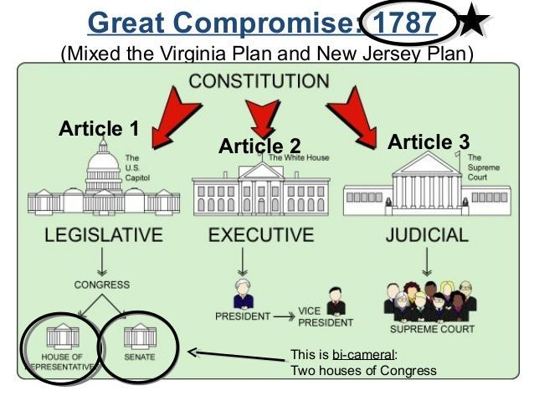
Great Compromise
One great issue facing the delegates to the Constitutional Convention was how to apportion representation in the new government's legislature. Under the Articles of Confederation, each state had one vote, which put each state on equal footing regardless of population. States with large populations wanted more influence in the government and supported James Madison's proposal known as the Virginia Plan. Under Madison's proposed government plan, representation in the nation's legislature would be proportional to each state's population. Thus, states like Virginia would have greater representation and voting power in the federal legislature. Virginia's population in 1797 was the largest of any state with approximately 692,000. The next closest state in terms of population was Pennsylvania with approximately 494,000. Virginia, and other large states, believed it was appropriate for them to have a stronger voice in making policy than a small state like Delaware, with a population of only 59,000 people.
States with smaller populations were reluctant to abandon the equality they had with larger states under the structure of the Articles of Confederation. To counter Madison's Virginia Plan, the small states supported the New Jersey Plan that featured a legislative branch in which all states were equally represented. Essentially, the New Jersey Plan would have maintained the government structure from the Articles of Confederation but expanded the powers Congress would have over the states. The result of the two proposals was a divided Constitutional Convention in which the large states and small states both vied for legislative power.
Compromise was essential for the Constitutional Convention to succeed in satisfying the contending viewpoints on the framework for a new government. Delegates to the Constitutional Convention settled the issue of representation in Congress by approving the Great Compromise. This compromise helped "save" the Constitution by settling the dispute between states with large populations and states with small populations. The compromise called for the creation of a legislature with two chambers, a bicameral legislature. There would be a House of Representatives in one chamber, with representation based on population. The second chamber would be a Senate, with equal representation for all states. Proposed legislation had to achieve a majority vote by both chambers of the legislature before being passed on to the newly created executive branch to be signed into law.
Three-Fifths Compromise
Another divisive and controversial issue that confronted delegates at the Constitutional Convention was slavery. Though slavery existed in all the states, southern states depended on slave labor because their economies were based on producing cash crops. When it became clear that states with large populations might have more representatives in the new national government, states with large slave populations demanded to be allowed to count their slaves as a part of their population. Northern states resisted. Both sides compromised and agreed to the provisions of the Three-Fifths Compromise in the final plan for the new government. The Three-Fifths Compromise allowed states to count three-fifths of their slaves when calculating their entire population. It was known as the Three-Fifths Compromise because it stated that each slave would count as "three-fifths of a person." In other words, for every five slaves, a state would be credited for having three people. Meanwhile, debate about the slave trade resulted in a slave trade compromise. Under this agreement, Northerners and delegates from the Upper South (Maryland and Virginia) who opposed the slave trade agreed to allow it to continue for twenty years, after which time Congress could impose regulations. This was important to delegates from the deep South who insisted that their economy could not survive without the slave trade. US involvement in the Atlantic slave trade finally ended in 1808. Slavery, however, continued until 1865.
The deliberations and negotiations concerning the key issues of representation, limited government, and slavery lasted through the summer of 1787. Thirty-nine of the fifty-five delegates signed the final draft of the new United States Constitution on September 17, 1787. The proposed Constitution was then sent to each state for ratification at state conventions.
d. Evaluate the major arguments of the Anti-Federalists and Federalists during the debate on ratification of the Constitution, The Federalist Papers, and the roles of Alexander Hamilton and James Madison.
Ratification of the Constitution
Writing the Constitution was just the first step in creating the new government. Before the Constitution could take effect, the states had to accept, or ratify, the document. As soon as the contents of the Constitution were published, a group of influential people spoke out against it. These people came to be known as the Anti-Federalists. Another group, known as the Federalists, promoted ratification of the document as it had been drafted at the Constitutional Convention. The two groups led the debate over the ratification process, each with sound arguments to support their viewpoints.
The Anti-Federalists believed the national government created by the Constitution would be too powerful and would eliminate the power of the states. This fear harkens back to the threats of despotism the patriots fought to eliminate during the Revolutionary War period. Anti-Federalists also argued that the Constitution did not describe the rights guaranteed to the states and to each citizen. Thomas Jefferson and Patrick Henry were prominent Anti-Federalists.
The Federalists did not agree that citizens were left vulnerable by the new Constitution. Instead, Federalists argued that listing within the document specific rights guaranteed to citizens would in effect LIMIT the rights of citizens to only those listed. They believed the government created by the Constitution was designed to protect citizens from the concentration and abuse of power at the federal level through the limited government structure they painstakingly created at the Constitutional Convention. Alexander Hamilton and James Madison were leading Federalists. Madison played a key role in drafting the Constitution and is often referred to as the "Father of the Constitution."
Each state held its own ratification convention where these diverging arguments were debated. Nine states were needed to secure the Constitution as the new framework for the United States' government. In some cases the state conventions argued the delegates of the Constitution Convention had overstepped their authority when they did not simply revise the Articles of Confederation. Other conventions quickly ratified the new Constitution with the belief that a stronger federal government would save the nation from succumbing to the weaknesses of the Articles of Confederation. Five states (Delaware, Pennsylvania, New Jersey, Georgia, and Connecticut) ratified the Constitution very quickly.
The Federalist Papers
Virginia and New York were quite divided over whether to ratify the Constitution and critical debate ensued. To counter the Anti-Federalist efforts, James Madison, Alexander Hamilton, and John Jay wrote a series of 85 articles over many months that supported ratification of the Constitution and explained the intent behind its major provisions. These articles, written by the leading Federalists under the pseudonym "Publius," were known as The Federalist Papers. The essays laid out a series of reasoned arguments designed originally to persuade the people of New York that the structure of the new Constitution actually protected and strengthened the United States. Key to these arguments was the use of the Constitution itself to illustrate how the Anti-Federalists did not need to fear that the document left the government susceptible to any one branch seizing too much power. The continued debate between the Federalists and Anti-Federalists threatened to derail ratification of the Constitution.
Document Analysis 3
“The powers delegated by the proposed Constitution to the Federal Government, are few and defined. Those which are to remain in the State Governments are numerous and indefinite. The former will be exercised principally on external objects, as war, peace, negotiation, and foreign commerce; with which last the power of taxation will for the most part be connected. The powers reserved to the several States will extend to all the objects, which, in the ordinary course of affairs, concern the lives, liberties, and properties of the people; the the internal order, improvement, and prosperity of the State.”
- James Madison, The Federalist No. 45
e. Explain how objections to the ratification of the Constitution were addressed in the Bill of Rights.
The Bill of Rights
One of the principle reasons that the American colonists revolted against the British government was the colonists' belief that Parliament had abridged colonial rights as guaranteed to them under the English Bill of Rights. When the Constitution was drafted, the Anti-Federalists felt that a strong central government could also infringe upon civil liberties. The Anti-Federalists would not ratify the new Constitution without the inclusion of a bill to protect citizen rights.
The Federalists indicated that they would support the addition of a Bill of Rights as one of the first orders of business in the new government if the Anti-Federalists would ratify the Constitution in its current form. The deal resolved the impasse and the Constitution was ratified by the required nine states upon New Hampshire's vote on June 21, 1788, thus putting the new United States Constitution into effect. The remaining states soon followed.
As was pledged during the ratification process, James Madison introduced a proposal to the new federal Congress for a Bill of Rights in June 1789. The proposal was approved separately by both houses of Congress by September 1789 and ratified by the states by April 1792. The negotiation between the Federalists and Anti-Federalists had succeeded in getting the Constitution ratified and the Bill of Rights was added as promised.
The Bill of Rights was passed in 1789 for the purpose of protecting individuals and states, the states chose to ratify ten. These are the first 10 amendments in the Constitution. The First Amendment guarantees citizens' freedom of speech, freedom of the press, freedom to petition the government, and freedom to assemble. It also protects freedom of religion and establishes the principle of separation of church and state through the free exercise clause and the establishment clause. The free exercise clause forbids Congress from making any law prohibiting the free exercise of one's religious beliefs. The establishment clause forbids Congress from establishing a religion. The Ninth Amendment simply states that the rights specifically mentioned in the Bill of Rights are not necessarily the only ones enjoyed by the people. The Tenth Amendment says that those powers not restricted by the Constitution, nor delegated to the US government, are reserved for the states. In other words, the Constitution grants the states the authority to decide certain matters of law.

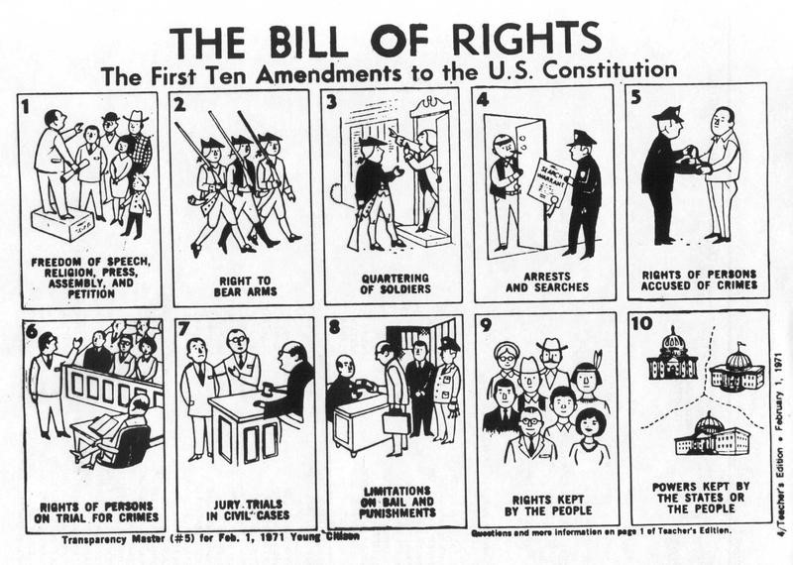
Document Analysis 4

