Unit 1: Colonial Era Guided Reading
SSUSH1 Compare and contrast the development of English settlement and colonization during the 17th Century.
a. Investigate how mercantilism and trans-Atlantic trade led to development of colonies.
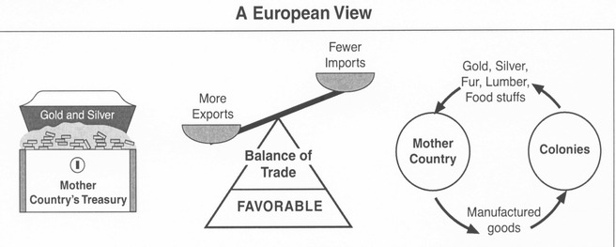
Document Analysis 1 Document Analysis 2
Mercantilism and Trans-Atlantic Trade
Although many English colonists came to North America searching for religious or political opportunity, it was economic opportunity that fueled the ambition of other English colonists, as well as, their mother country. Investors sought financial returns for their colonial ventures. England sought to extract resources from North America in order to compete with their European rivals for wealth and power. By the 1650s, England was heavily entrenched in trans-Atlantic trade based on mercantilism.
Mercantilism is an economic theory based on reducing a country’s imports while expanding its exports in order to maximize wealth. In the highly competitive European world of the sixteenth and seventeenth centuries, wealth equated to power. Thus, mercantilism inspired European governments, including England, to promote American colonies as sources of raw materials not readily available in the mother country. Some of the most important resources England plucked from its colonies included lumber, sugar, wool, tobacco, rice, and indigo. These raw materials were then used in England to produce manufactured goods for export to other European countries and back to the colonists in North America.
A favorable trade balance resulted for England in the colonial arrangement. Raw materials that were scarce in England were acquired from their colonial possessions. Simultaneously, the colonies were a ready market for the manufactured products produced in England from the raw materials. The trans-Atlantic trade network that resulted led to various colonial labor arrangements and restrictive policies to ensure England maximized its mercantilist potential.
England implemented a series of Navigation Acts in the mid-1600s to ensure a favorable trade arrangement with the colonies. The laws were designed to keep England’s own colonies from competing with their mother country by mandating three fundamental criteria for trans-Atlantic trade. First, all goods shipped to or from English North America had to travel on English ships. Second, any goods being imported to the colonies from Europe had to first be processed through an English port. And third, most colonial resources could only be exported to England. The Navigation Acts restricted the profits colonists could receive for their products, hindered the development of large-scale manufacturing in the colonies, and forced colonists to pay high prices for goods they were only allowed to purchase from England. One positive effect of the Navigation Acts on the colonies was the emergence of ship building as a viable industry in New England. Since the Navigation Acts required all goods to travel on English ships, there was an instant demand for more ships to be built from the lumber readily available in North America. Another effect of the Navigation Acts was increased smuggling of goods into North America by colonists who sought their own lucrative trade practices- regardless of legality.
Document Analysis 3
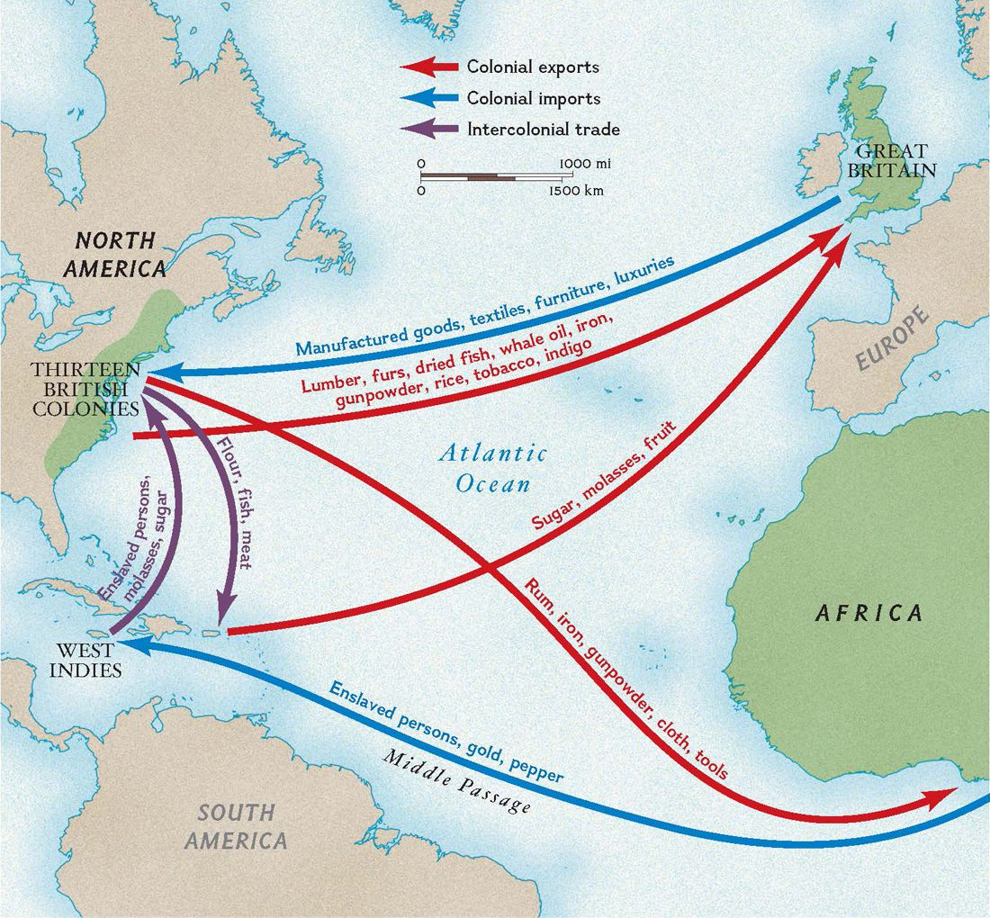

England’s trans-Atlantic trade flourished under the mercantilist system. Trans-Atlantic trade, sometimes referred to as Triangular Trade, often took a three-step voyage around the Atlantic rim. First, English ships loaded with rum, cloth, and other manufactured goods sailed to Africa, where they were traded for Africans as part of the slave trade. Then, in the Middle Passage (discussed further in SSUSH2), the slaves were transported on a brutal voyage to the Americas and sold there as a forced labor commodity to colonial landowners. The third step of the journey transported American raw materials to England to be made into the manufactured goods that would start the cycle again.
Colonial labor was critical for the production of materials England needed for a profitable mercantilist system. Labor needs were first filled through the use of indentured servants and then later by permanently enslaved Africans. Indentured servants were typically lower-class Englishmen who could not afford to pay for the voyage to North America but saw life in the colonies as an opportunity for economic advancement they would otherwise never have in England. Indentured servants worked for a landowner in exchange for their passage to North America. The landowner obtained labor and the indentured servant obtained the future opportunity to own land after working off their debt over a period of approximately four to seven years. Tensions began to develop over the continual need to supply land to newly freed indentured servants. African slaves were introduced as a labor source beginning in 1619 (discussed in SSUSH2). Eventually, plantation owners came to rely on African slaves as a more profitable and renewable source of labor.
England developed resource-producing colonies in North America primarily to fuel mercantilism and to amass wealth and power over their European rivals. The resulting trans-Atlantic trade system was regulated through Navigation Acts and led to various labor sources being used by colonists to meet the resource demands of England.

b. Explain the development of the Southern Colonies including but not limited to reasons established, impact of location and place, relations with American Indians, and economic development.
Development of the Southern Colonies
The Southern Colonies included Virginia, Maryland, Carolina (which eventually split into North Carolina and South Carolina), and Georgia. The location of the Southern Colonies, with the region’s rich soil and long growing season, fostered the development of strong agricultural producing colonies. Deep rivers and the distance of the fall line from the coast meant that inland farmers were able to ship tobacco, indigo, corn, and rice directly from their farms to European markets. The economic development of the Southern Colonies reflected this geological line. Subsistence family farms tended to develop north of the fall line. These farms grew primarily what the family needed along with a small cash crop used to purchase or barter for goods such as salt, gunpowder, lead, and iron tools. Commercial farms tended to develop south of the fall line and grew primarily high yield, labor intensive cash crops such as rice, tobacco, and indigo. As a result, slave labor was more common south of the fall line while less common north of the same line.
Relations with American Indians in the Southern Colonies began somewhat as a peaceful coexistence. As more English colonists began to arrive and encroach further into native lands, the relationship became more violent. The complexity of the interactions with American Indians in the Southern Colonies grew as the region’s economic development grew. Once large-scale cash crops of tobacco, rice, and indigo proved highly profitable in the mercantilist system, more colonists arrived seeking economic opportunity. The growing English population in the Southern Colonies required more of the American Indians’ land for crop cultivation, which fueled increased tension between the groups.

c. Explain the development of the New England Colonies including but not limited to reasons established, impact of location and place, relations with American Indians, and economic development.
Development of the New England Colonies
The New England Colonies (Massachusetts, Rhode Island, Connecticut, and New Hampshire) were marked by poor, thin, rocky soils and a relatively short growing season that made farming difficult. However, plentiful forests and proximity to the sea led New Englanders to eventually develop a thriving ship building industry. Fishing, whaling, and commercial trade from harbors such as Boston became important economic engines for the region. New Englanders became the merchants of the colonies and New England-based ships were the carriers of colonial goods in the trans-Atlantic trade.
Whereas England’s Southern Colonies were developed for primarily economic gain, the New England Colonies developed initially as religious outposts by various subjugated groups. In particular, Calvinists in England faced increased persecution for their desire to reform the Anglican Church (also known as the Church of England) and their opposition to the growing power of the English monarchy. These religious dissenters, known as Puritans, disagreed with the Protestant Anglican Church’s continued use of Catholic rituals and traditions. The Puritans wanted to “purify” their Protestant sect of its heavily entrenched Catholic features. Although the Puritans came to North America for religious reasons, they were not religiously tolerant of those who did not fully comply with their views of religion.
American Indians were viewed by the Puritans as needing to be saved from their sinful ways since they were not Christians. In the early years of English colonization, the relationship between the American Indians and the Puritans was based primarily on trade and diplomacy given that the Englishmen were greatly outnumbered. The Puritans did not openly embrace the American Indians but relied on them for help in the difficult early years for survival. As the English population increased, so did the conflict with natives of the area. A series of bloody wars (King Philip’s War and the Pequot Wars) ensued during the colonial period between the Puritans and the American Indians of New England.
There were two types of Puritans – seperatist Puritans and non-seperatist Puritans. The seperatist Puritans, also known as Pilgrims, were no longer interested in simply reforming the Anglican Church. Instead, the Pilgrims planned to organize a completely “separate” church without the King’s influence- hence the name seperatist Puritans. The non-seperatist Puritans, or simply Puritans, wanted the Anglican Church to “purify” itself of what they saw as problematic Catholic traditions. They wanted to remain part of the Anglican Church if it could become the truly Protestant faith it claimed to be. Using their influence and wealth, the Puritan leadership was able to acquire a majority share in a trading company. Using the trading company as a front, the Puritans moved the headquarters of the London Company of Plymouth to Massachusetts. Afterwards, many Puritans and their families immigrated to the American colonies in order to escape persecution. Thus, the New England Colonies were established by separatist Pilgrims at Plymouth in 1620 and the non-separatist Puritans at Massachusetts Bay in 1630. Like the Virginia colonists, the New England settlers had similar problems acclimating to their new environment and suffered substantial losses in the early years. Eventually in 1691, Plymouth and Massachusetts Bay colonies were combined into one Massachusetts colony.
The Pilgrims set sail on the Mayflower in 1620, with approximately 100 passengers, headed for Virginia. After a storm blew them off course, their landing on the North American coast was a few hundred miles north of their intended destination. The group decided to stay in the undeveloped area and create a new colony called Plymouth. Before disembarking the Mayflower, the Pilgrims created and signed the Mayflower Compact. The document is important in the study of the early colonial period in that it was a pledge by the colonists to govern themselves through majority rule.
The Puritans tightly controlled the political and social structure of the community. Communities were run using town meetings. Voting rights were limited to men who belonged to the church, and church membership was tightly controlled by each minister and congregation. Towns were run as direct democracies with each voting member having a direct role in the administration of government. The church was the central force in governing the community. As a result of their strict religious beliefs, the Puritans were not tolerant of religions that differed from their own. Frequently, those who disagreed with Puritan ideology and practices were banished from the colony.
Initially, relations with the American Indians living in the coastal regions of New England were cordial. Each side engaged in a profitable exchange of trade goods. However, as the English colony grew in size, so did the tension between the Puritans and Native Americans. King Philip’s War (1675- 1676) was an early and bloody conflict between English and regional American Indian tribal groups. King Philip, or Metacom, was the regional leader of the American Indians. The conflict originated as the Puritan community spread out from Boston and took more land from the natives. Additionally, some tribal members had converted to Christianity disrupting traditional political and cultural ties among the region’s tribes. Many colonists died in the war, but it also caused a heavy loss of life among the American Indian population. As a result, large areas of southern New England were opened to English settlement.

d. Explain the development of the Mid-Atlantic Colonies including but not limited to reasons established, impact of location and place, relations with American Indians, and economic development.
Development of the Mid-Atlantic Colonies
The Dutch established the North American colony of New Netherland in 1614. The colony, held by one of England’s European rivals, was founded as a private money-making venture by the Dutch. Trade was centered around New Netherland’s port of New Amsterdam (present day New York City). The Dutch colony’s location between England’s Southern and New England colonies in North America made it attractive for English annexation. England did seize control of New Netherland from the Dutch in 1664. New Netherland’s governor, Peter Stuyvesant, negotiated the colony’s transfer to English control without much resistance. The Mid-Atlantic colonial region is noted for its significant cultural and religious diversity due to its unique transition to England as an already established colony.
The English Mid-Atlantic Colonies (New York, New Jersey, Pennsylvania, and Delaware) that were created from the previous Dutch New Netherland colony were geographically fortunate to have good harbors and river systems that significantly shaped their development. The Hudson and Delaware Rivers provided highways to the interior of North America. Furs acquired from American Indians through trade for European goods, such as iron tools and firearms, were transported toward the coast along swift rivers. Later, the region’s farmers were able to use the rivers to ship wheat and other agricultural goods to markets in other colonies and Europe. The rivers also provided the colonists of the mid-Atlantic region with access to manufactured goods imported from European markets. Harbors in cities such as Philadelphia and New York City allowed the Mid-Atlantic Colonies to grow into major commercial hubs for all of England’s American colonies.
American Indians of two major language groups, Algonquian and Iroquois, resided in England’s Mid-Atlantic Colonies. The natives who resided there were typically relied upon for trade with the English and not the target of war, as was often the case in the other English colonial regions. Pennsylvania, in particular, treated the American Indians with more respect as evidenced by William Penn’s insistence on compensating the natives for their land.
The Mid-Atlantic Colonies geographic position united the American coastline under English control. Economically, the region’s colonies developed into strong merchant centers similar to their New England neighbors to the north. However, the Mid-Atlantic Colonies also farmed significant quantities of wheat and corn, similar to the cash crop production of their southern neighbors. The MidAtlantic Colonies were truly a bridge between the large-scale farmers of the Southern Colonies and the merchants of the New England Colonies due to the geography and climate of the mid-Atlantic region.
Pennsylvania
William Penn was granted land in North America as repayment of a debt the king owed his father, an admiral in the English navy. William Penn belonged to a religious group known as the Quakers. The Religious Society of Friends, as the Quakers were formally known, were persecuted in England for their beliefs. The basic ideology followed by Quakers is that everyone possesses an “inner light” through which individuals are capable of their own religious interpretation without the need for formal clergy. Women also were afforded full participation in the faith, as they too possessed an inner light. Pennsylvania was established as a Quaker colony in 1682.
The Quakers believed in religious toleration and fair treatment of the American Indians in the area. Penn advertised his colony throughout Europe and quickly attracted over 1000 settlers in the first year. Philadelphia rapidly grew to be a vibrant port city engaged in the trans-Atlantic trade of goods. Because of the religious and cultural tolerance practiced by Penn and the Quakers, Pennsylvania exemplifies the diversity for which the Mid-Atlantic Colonies are known.
SSUSH2 Describe the early English colonial society and investigate the development of its governance.
a. Describe European cultural diversity including the contributions of different ethnic and religious groups.
European Cultural Diversity
English colonial society was made up of diverse ethnic groups and individuals who arrived in North America with different goals and under different circumstances. The colonies grew quickly once the initial challenges of settlement were overcome. Economic opportunity and the social mobility that came along with financial gain attracted colonists from many different locations to make the journey to America. Traditions of local self-government also emerged in the different colonies during England’s early period of salutary neglect. Although economic opportunity, religious freedom, and self-government came to be colonial traditions embraced by the colonists, not all people came to the English colonies by choice. Africans, brought against their will to America on the Middle Passage, were forced into permanent slave labor arrangements and did not benefit from the emerging successes of colonial society.
Various European cultures came to be represented in England’s American colonies. Beginning with the first permanent settlement at Jamestown in 1607, approximately 250,000 Europeans migrated to the colonies by 1700. By the outbreak of the American Revolution, the population of England’s colonies in North America was approaching 2.5 million. Most immigrants to the colonies were from England during the early period, but over time immigrants began coming to America from other European countries.
The European ethnic groups living in America during the colonial period included immigrants from Scotland, Ireland, and Germany. Various “push factors” led immigrants from these countries to seek opportunity in England’s American colonies. Scottish immigrants had easier access to the colonies after the political union of Scotland and England was formalized in 1707. Most of the Scottish and Irish immigrants to America settled in the mountainous backcountry frontier located west of established colonial settlements. The unique speech patterns and folk songs characteristics of the United States’ Appalachian region can be traced to the Scottish and Irish colonial immigrants who settled there in the decades prior to the Revolutionary War.
German immigrants also began to populate England’s American colonies during the early period. Germany was divided into many small rival principalities whose quests for power led to violence. To finance each principality’s defense, the common people living there were taxed heavily and often forced into military service. The strict control German princes exerted over their lands left the commoners searching for better financial opportunities and autonomy. William Penn recruited these disgruntled Germans to immigrate to his new colony of Pennsylvania. After coming to America, the German immigrants reported back to their kin in Europe that abundant land, plentiful food, cheap taxes, and no forced military service was the way of life in Pennsylvania. Thus, more Germans arrived in America seeking land and opportunity.
The Mid-Atlantic colonies came into English possession as already ethnically diverse places. The cultures represented in these colonies included Dutch, Swedish, Finnish, German, Scottish, and French. Because the diversity beyond English culture was so great, the various groups had to work together and tolerate the differences between them. Elements of these various European cultures, from language, style, food, and architecture, came together to eventually create a basis for a uniquely American culture.
Various religious groups also made their way to England’s American colonies seeking opportunity for the free practice of their faiths. Puritans firmly established their religious values in the New England colonies of Massachusetts Bay and Plymouth. Although the Puritans immigrated to the colonies to escape religious persecution, they did not tolerate other religious practices in their own colonies. Maryland was originally established as a colony for Catholics to worship freely and legislated their religious protection through the passage of the colony’s Acts of Toleration in 1649. Rhode Island was accepting of all religions including followers of Protestant sects, Catholicism, Judaism, and Quakerism. The Quakers, however, settled primarily in Pennsylvania and were also very tolerant of other faiths.
The diversity of religions, particularly in Rhode Island and Pennsylvania, meant that no one faith held a majority in those colonies. Therefore, no one religion became the established religion in those colonies. The American tradition of separating church and state was born from this religious diversity in the colonies. The foundation for cultural and religious diversity in the United States was set during the early colonial period with the planting of English colonies that became home to a wide array of immigrants from various countries and religious backgrounds.
b. Describe the Middle Passage, the growth of the African population, and contributions including but not limited to architecture, agriculture, and foodways.
Document Analysis 4 Document Analysis 5
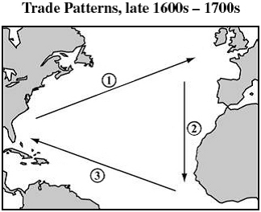
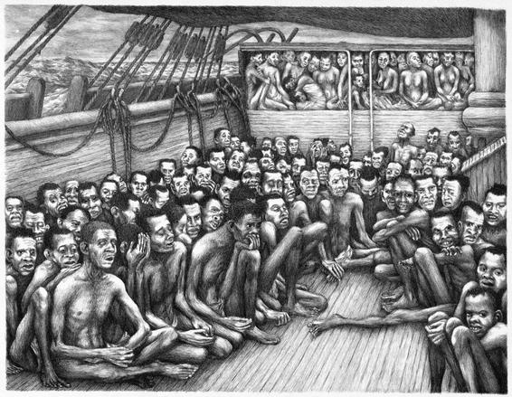

The Middle Passage
As tobacco farmers and other cash-crop farmers prospered in the colonies, they greatly expanded the size of their farms. Because of the resulting need for workers to plant, grow, and harvest the crops, farmers turned to African slaves to fulfill their growing labor needs. The first Africans arrived in Virginia in 1619. During the colonial period, approximately 250,000 Africans were imported to the colonies. The vast majority of these slaves were concentrated in the agriculturally intensive Southern Colonies, although all of the English colonies allowed and had slaves during the colonial period.
The African slaves who were forced to fill this labor role in the American colonies were brought to North America on crowded and dangerous slave ships along the previously mentioned Middle Passage portion of the trans-Atlantic trade routes. The slaves were originally captured through the African slave trade within the African continent and then brought to the West African coast for barter with European slavers. Rum, cloth, weapons, and other manufactured goods from Europe were traded for Africans. Between three and four hundred slaves were packed into cargo holds of slave ships bound for North America. Sickness, fear, and brutality was the common experience for slaves on the Middle Passage. About two of every ten slaves died during the Middle Passage.
There was no single African culture. People brought from west Africa as slaves represented a large number of different cultures. In an effort to control the slaves, slave owners attempted to strip away the cultural identity of their slaves and sought to replace it with the culture of the plantation or region to which the slave was brought. However, the physical isolation of slaves from their masters led to the creation of a new blended culture rather than the replacement of one culture over another. What resulted was the creation of a unique African American or Black culture.
Foods, such as okra, watermelon, yams (sweet potatoes), rice, and even grits have been attributed to cultural blending of African and European cultures. The practice of blending different African tribes on a single plantation led to the creation of blended language patterns such as Creole in Louisiana and Gullah in coastal Georgia and the Carolinas. Economically, coastal South Carolina and Georgia owed its prosperity to the introduction of rice that was propagated by West African and West Indian slaves. Ironically, it was this same rice production that served as a food source for West Indian sugar plantations whose insatiable labor demands expanded slavery in the European colonies.
Architecture is another topic for which African influences can be detected in America’s development. Slave labor often built the homes and buildings of their American masters. Over time, traces of Africanism found their way into the styles of buildings being constructed. The “shotgun” style home has been traced to a dwelling style popular in Haiti and even further removed to a style of hut popular among the Yoruba people of western Africa. A shotgun house is characterized as being very narrow and long with a front porch. The simplistic style, with its entrance being on the short side of the home, is different from European styled homes. The homes are one room wide and two to three rooms deep with only doors separating the rooms – no hallway. Archaeologists also suggest that some of the building materials used on Georgia plantations may have African roots. The wattle and daub and tabby material used in early Georgia coastal construction is similar to the woven sticks covered in mud or clay technique of West Africa Ashanti homes.
c. Describe different methods of colonial self-governance in the period of Salutary Neglect.
Salutary Neglect
In 1721, Robert Walpole became the first Prime Minister in England. His approach to the colonies became known as Salutary Neglect. Walpole believed that the colonies would become more economically productive if they were not restricted by cumbersome policies that limited their ability to trade, such as the Navigation Acts. From the 1720s until after the French and Indian War in the 1760s, the colonies were less restricted in their ability to build up their own trade networks and govern themselves locally because of the policy of Salutary Neglect. As long as England was receiving the colonial resources they needed to maintain production under the mercantilist arrangement, there would be less oversight of the colonies by the English Crown. The colonies had always been somewhat independent of English control due to distance limitations, structure of the colonial governments, and the greater proportion of eligible voters in the colonies. The methods of colonial self-government that existed during the period of Salutary Neglect firmly established the tradition of independence that would later lead to revolution between England and her colonies. The political structure of each colony by the time of the Revolutionary War consisted of a governor and an elected legislature. The earliest of the elected legislatures, the House of Burgesses, had been established shortly after Jamestown’s founding. Colonial legislatures, such as Virginia’s, had long traditions of making local policies and were made up of locally elected colonists. Taxes were levied by these colonial representatives and established the tradition of local taxation by locally elected representatives. Many New England colonies had town meetings that met regularly for people to vote directly on public issues. Voting in the colonies was often restricted to only white males who owned at least some land. Even so, this criteria encompassed a much higher proportion of citizens than other countries - including England. Religious restrictions had even been removed from the New England colonies’ voter eligibility by the time of the American Revolution, which further expanded the tradition of local colonial participation in governing.
There was also an expectation that emerged in the colonies that the local legislatures would be responsible for looking out for the interests of all colonists and not just the wealthy. This concept played out dramatically with the events surrounding Bacon’s Rebellion in Jamestown in the late 1670s. Former indentured servants had worked off their debt but could not afford land in the township itself. Instead, they had to move farther into the frontier and often faced conflicts over land with the area’s American Indians. These poor citizens payed taxes and expected the House of Burgesses to provide protections for them, even though they lived further out from the wealthy Jamestown community. Nathanael Bacon led these poor citizens first against the American Indians and then against the Jamestown elite, including the Royal Governor William Berkeley. Bacon’ Rebellion, between the poor frontier colonists and Virginia’s colonial government, established an expectation in America that the government would work for the good of all citizens – not just the wealthy.
The tradition of English colonial self-government began early with the pledge of majority rule under the Mayflower Compact and the establishment of colonial legislatures. During the period of Salutary Neglect, the role of these local assemblies and town meetings expanded. It was during this time that the English government, following the Glorious Revolution, scaled back their political oversight of the colonies as long as the economic resources were being provided to England. Political autonomy and self-government in the colonies grew to be an expectation and formed an independent American identity that ultimately led to war between England and her colonies.
d. Explain the role of the Great Awakening in creating unity in the colonies and challenging traditional authority.
The Great Awakening
The Great Awakening was a religious movement influenced by the revivals that were sweeping through England, Scotland, and Germany in the 1730s. It spread from Europe to the colonies in the following decade and continued until the eve of the American Revolution. The revival placed an emphasis on individual religious experience rather than religious experience through church doctrine. The Great Awakening challenged established authorities as the colonists questioned the need to follow not only the Church of England but also the orders of the English monarchy and its authorities. The idea of the shared struggle that Awakening ministers had spoken of was easily transferred to the shared struggle for independence that was beginning to unify the colonies.
The Great Awakening was in part a reaction to the Enlightenment, which emphasized logic and reason and stressed the power of the individual to understand the universe based on scientific laws. Similarly, individuals grew to rely more on a personal approach to salvation than church dogma and doctrine through a personal understanding of scriptures. Although the Enlightenment was really a movement of the intellectual elite, the Great Awakening had stronger appeal across all cross sections of society in each of the thirteen colonies.
Ministers such as Jonathan Edwards, William Tennent, and George Whitefield began to urge Christians to adopt a more emotional involvement in Christianity through fervent prayer and personal study of the Bible. Their sermons were emotional, appealing to the heart not just the head. New denominations such as Baptists, Methodists, and Presbyterians gained members and challenged some of the old established colonial denominations such as the Congregationalist Puritans in New England and the Anglicans in the South. Practicing religion became an emotional experience in addition to an intellectual experience.
The American colonies, especially those in New England, had been founded on the idea that government ruled on the basis of a covenant relationship with God and the people (e.g., The Mayflower Compact). The governance structure of the new churches reflected this idea as churches appointed their own ministers and administered their own churches. This sense of independence was soon reinforced by the political ideas of John Locke’s social contract and Thomas Paine’s emotional appeal for independence.

