Unit 10- World War II and Cold War Guided Reading Packet
SSUSH19 Examine the origins, major developments, and the domestic impact of World War II, including the growth of the federal government.
a. Investigate the origins of U.S. involvement in the war including lend-lease and the Japanese attack on Pearl Harbor.
U.S. Enters World War II: Lend-Lease Act
The United States was cautious in its initial involvement in World War II. The events in Europe threatened American allies and trade. Danger was spreading through Europe in the 1930s with the rise of dictators, who desired to expand their influence by taking over vast areas. Many Americans were reluctant to get involved in this European conflict after the events of World War I. It was not until Japan attacked the United States at Pearl Harbor that there was unified support for America’s entry into the war.
Part of the public reluctance to get involved in the war resulted from a mid-1930s Congressional investigation, which indicated banking and munitions interests helped push the United States to enter World War I for their own financial gain. This evidence led Congress to pass a series of neutrality laws that made it illegal to sell arms or make loans to nations at war. The fourth of these acts was passed in 1939 as a recognition of the increasing threat Nazi power posed to Western European democracies. The 1939 Neutrality Act permitted the sale of any materials, including arms, to nations at war on a “cash and carry” basis. This was a way for the United States to help restrict the spread of Nazi influence while at the same time remaining neutral. The cash and carry provision meant that buyers would have to pay cash and send their own ships to American ports to pick up the supplies they were purchasing from the United States. The British and the French were the only countries financially in a position to meet the criteria of the cash and carry Policy. This arrangement kept American ships from being sunk by the German submarines patrolling the Atlantic Ocean.
The Roosevelt administration opposed the proposals because he believed that the laws might restrict the United States if Europe or China needed help in the future. However, the president had no choice but to sign the Neutrality Acts into law because he needed to insure that Congress would pass the remaining parts of his New Deal legislation. Even though the United States was declaring neutrality in World War II, the nation was still supporting the Allied Powers through the transfer of goods.
The cash and carry provision lasted until early 1941. By that time, Great Britain was strained financially to meet the criteria for the cash and carry policy. Nine months before Pearl Harbor, Congress passed the Lend-Lease Act, which created a pathway for American goods to still support the British war effort even though they were short on cash. Under the new provisions of Lend-Lease, the United States could lend military equipment and supplies to any nation the president said was vital to the defense of the United States. Roosevelt approved $1 billion in Lend-Lease aid to Great Britain in October 1941. When the United States entered World War II, $50 billion worth of equipment and supplies had already been sent to Great Britain, France, the Soviet Union, and China. These nations became allies of the United States after the attack at Pearl Harbor led to the American declaration of war.
Document Analysis 1
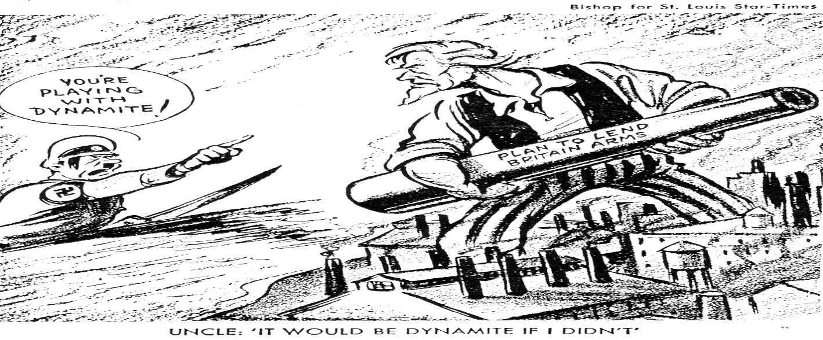

U.S. Enters World War II: Japanese Attack on Pearl Harbor
The December 7, 1941 attack on the United States at Pearl Harbor evolved from Japan's desire to conquer all of Asia for its own use. Japan was, and still is, a resource-poor nation. In order to keep its industries going and to feed its people, the Japanese government began a policy of expansion in the 1890s. Japan's military targeted the weaker nations of China and Korea and captured territory from both nations. The United States was angered by Japan's aggression in China. Under U.S. policy, all nations should be able to trade freely in China and respect their territorial integrity. Japan invaded Manchuria in 1931 and engaged China in a full-scale war in 1937. China was quickly conquered, except for the southwestern provinces.
The neutrality laws of the early 1930s prevented the United States from giving aid to the Chinese. However, the passage of the Lend-Lease Law in 1939, allowed the United States to lend money to the Chinese war effort. In 1940, Germany conquered France and the Netherlands and threatened Great Britain. The conquered nations also had rich colonial holdings in Asia. Japan sensed these colonies would be easy to acquire and positioned its military to conquer the entire region. In September 1940, the Japanese occupied French Indochina threatening British Malaysia, the Dutch East Indies, and the American Philippines. The United States immediately placed an embargo on airplane parts and aviation fuel. The United States also re-positioned the Pacific fleet from San Diego to the Hawaiian Islands. In July 1941, the United States placed a total financial and oil embargo on Japan.
The Japanese felt they were being directly threatened by the United States and began to plan operations for the take over of the East Indies, Malay Peninsula, and the Philippines. To prevent any counter-attack, the Japanese military felt it was necessary to destroy the American Pacific fleet. On the morning of December 7, 1941, the Japanese navy launched a surprise attack on the United States Navy base at Pearl Harbor, Hawaii. Over 2,400 Americans were killed and 1,178 more were wounded, 19 ships were damaged, and over 300 aircraft were destroyed. The Japanese attack brought the United States officially into World War II.
b. Examine the Pacific Theater including the difficulties the U.S. faced in delivering weapons, food, and medical supplies to troops, the Battle of Midway, the Manhattan Project, and the dropping of the atomic bombs.
Pacific Theater: The Battle of Midway
The United States entered World War II after the attack at Pearl Harbor. There were two theaters of war. American forces fought in both the Pacific and in Europe. Fighting in the Pacific Theater presented some extra strategic difficulties and ultimately led to the use of atomic weapons to end the war.
The distance across the Pacific was three times the distance from New York to Great Britain. It could take up to five months for supplies to get from California to Australia. The decision to prioritize the war in Europe sent the best and greatest amount of equipment to Europe. This allocation of resources meant that forces in the Pacific faced outdated equipment and shortages until the United States' industrial capacity could catch up with demand. Additionally, there was little or no infrastructure to transport and store supplies in the Pacific once they arrived in the theater. Finally, the climate of the Pacific region was difficult to manage and caused food supplies to spoil. These conditions led to the Allied policy of Island Hopping across islands that served as landing strips. These locations allowed air bombardments of Japanese fortifications. The Pacific Theater presented unique challenges for the United States in delivering food, weapons, and medical supplies to troops in the region during World War II.
Headway was made in the Pacific six months after the Japanese attack on Pearl Harbor. The United States won a sea battle against the Japanese Navy that was a turning point in World War II. The Japanese tried to trap and sink America's aircraft carriers near Midway Island, which was an American refueling station for ships and airplanes. The United States had gained intelligence information that the attack was coming and lured the Japanese into the waiting American forces. In the Battle at Midway, the United States destroyed four Japanese aircraft carriers while losing only one American carrier. The American victory at Midway is regarded as the most important naval engagement of the Pacific campaign. The success was also a huge morale boost for the United States. The Japanese never recovered from this defeat, which enabled the United States to gain control of other strategic Pacific Islands.
Pacific Theater: The Manhattan Project
Eventually, the Island Hopping campaign in the Pacific led President Truman to a critical juncture. President Roosevelt had died in early 1945 and Harry Truman was the new President responsible for making the decisions regarding the conduct of the war. Should the United States use a new atomic weapon or would a military invasion of Japan's mainland be necessary to achieve victory in the Pacific? The development of the atomic weapon had been a tightly held secret and would certainly cause significant damage if used in battle.
The Manhattan Project was a code name for a secret research and development program whose goal was to build an atomic weapon during World War II. European scientists who fled Germany in the early 1930s, including Albert Einstein, feared that German physicists were developing an atomic weapon for Hitler. The scientists urged Roosevelt and Churchill to create a similar program. United States General Leslie Groves led the development of numerous research labs, where three atomic weapons were ultimately created. One of the research labs was the Los Alamos facility in New Mexico.
The Los Alamos facility was the location of the first atomic weapon test. Plans for an Allied invasion of Japan were underway and estimates suggested there could be as many as one million Allied casualties. The successful atomic weapon test led to the creation of two working bombs that were subsequently used against the cities of Hiroshima and Nagasaki in a successful bid to convince the Japanese to surrender. The use of the bombs eliminated the need for an invasion of the Japanese mainland- thus saving countless American lives. The military’s use of these atomic bombs led to two important developments. First, the surrender of the Japanese government was secured, which ended World War II. Second, the development of the atomic bomb spurred a new, more dangerous arms race between the Soviet Union and the United States.
The creation of government sponsored and financed research-and-development labs became a model for future weapons development programs. These programs were led by military officers and used research scientists to produce technology necessary for national defense. Similar research and-development models were used by civilian corporations for creating goods that could be used by the government and civilians. The mass production of isotopes led to the development of nuclear medicine and the use of atomic energy for electrical power.
c. Examine the European Theater including difficulties the U.S. faced in delivering weapons, food, and medical supplies to troops, D-Day, and the Fall of Berlin.
European Theater: D-Day
In addition to fighting in the Pacific Theater, the United States was also engaged in the European Theater of World War II. The United States was the prime supplier of war material to the Allies. To supply the European allies, it was necessary to cross the Atlantic Ocean. It took between ten and fifteen days for a convoy to cross the Atlantic. Along the way, Allied shipping had to fight German submarines and aircraft. The American ships and their cargo was needed to feed and supply the Allied soldiers and the British civilian population. Initially, the British Isles served as a supply depot while the Allies built up their forces to invade the continent. After landing troops on the coast of France and Italy, supplies followed the forces inland using the existing road networks. However, the farther the Allied forces moved from the coast, the longer it took to get supplies to the front lines. Gasoline was a particular problem for Allied forces that relied heavily on mobile warfare. In fact, the Allied advance stalled in November 1944 because the armor units ran short of fuel. Lend-leased goods were shipped to the Soviet Union through the German submarine defenses around the Scandinavian Peninsula and around Africa to the Persian Gulf and through Iran.
One of the most significant events in the European Theater of World War II was the Allied invasion of Normandy, France, which is often referred to as D-Day. This victory began the Allied advance to reclaim Europe. D-Day was the code name for the first day of Operation Overlord, the Allied invasion of Nazi-occupied France. It remains the largest seaborne invasion in history, with over 156,000 men crossing the English Channel in 6,939 vessels. When the Allies landed at Normandy, the German troops occupying the heavily fortified French coast were unprepared. They had been tricked by the Allies into thinking that the Allies would attack France in a different location. Although the Allies met heavy resistance, the invasion went almost exactly according to plan. As a result of the operation's success, American and British forces were able to maintain a permanent beachhead in mainland Europe to resupply their forces and push east to Germany. The geographic advantage gained by the invasion marked the beginning of victory for the Allies in Europe.
European Theater: Fall of Berlin
The Battle of Berlin was one of the final battles of the European Theater during World War II. Two Soviet army groups attacked Berlin from the east and south, while a third attacked German forces north of Berlin. The Soviets lost 81,116 men taking the city, while the Germans lost 458,080 trying to defend it. The battle was one of the bloodiest in history. Adolf Hitler was in Berlin during the battle and before it ended with Soviet occupation, he and many of his followers committed suicide. The city's defenders surrendered on May 2, 1945, but fighting continued outside the city until the formal German surrender, known as V-E Day, ended the war on May 8, 1945.

d. Investigate the domestic impact of the war including war mobilization as indicated by rationing, wartime conversion, and the role of women and blacks.
Document Analysis 2
Image A | Image B | Image C
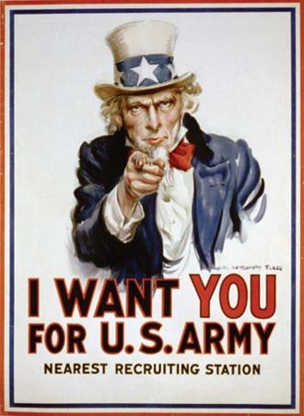 | 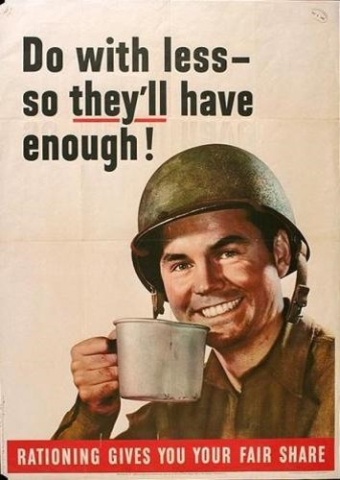 | 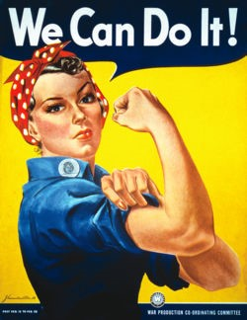

War Mobilization
When the United States fully and officially engaged in World War II, the nation went into a total war effort. To orchestrate the conversion of privately owned manufacturing companies to supply the United States' war effort, the Roosevelt administration created the War Production Board. The War Production Board's responsibility was to regulate the production and allocation of materials and fuel. The board stopped the production of non-essential goods, such as automobiles, and imposed a rationing system for gasoline and rubber. Civilian industrial plants soon began producing war goods in great quantities. Plants that produced silk ribbons instead produced parachutes, typewriter plants produced machine guns. Ford, General Motors, and other automobile manufacturers produced great numbers of airplanes, tanks, trucks, and artillery pieces. One of the most remarkable feats was the creation of the Liberty Ship by Kaiser Aluminum. These ships were created in an assembly line fashion such that eventually a single cargo ship could be produced in just 42 days.
Wartime Conversion and Rationing
Food rationing began in 1942. Items such as sugar, meat, butter, canned vegetables and fruits all required coupons (also known as rationing stamps). Allotments were based on family size. Families that were able, planted Victory Gardens to supplement their diets. Rationing of gasoline, sugar, and tires led to some black market deals, although most Americans bore the hardships with a good spirit. Consumers knew everyone was in the same position and the goods they gave up were destined for servicemen and women overseas.
Role of Women
At the outbreak of the war, women who already had jobs found that the choices of occupation and the rate of pay suddenly changed for the better. Women served in many different capacities during the course of World War II. Some women served in the military. There were 216,000 women who volunteered for service in the various branches of the Armed Services. In order to meet the demand for labor, the United States government began a campaign to lure women into the workforce. The government created a fictional ideal woman known as "Rosie the Riveter" to appeal to women's patriotism. Women worked in many different areas including munitions, aircraft plants, shipyards, and in more traditional positions as clerks and secretaries. By the war's end, 18 million women had entered the work force.

Role of Blacks
Black workers, despite receiving training in government approved programs, were denied access to defense jobs. Many employers refused to hire Black workers. They believed that Blacks could not be trained for complex mechanics jobs or for aircraft construction. A. Philip Randolph, a Black labor organizer, had created the Brotherhood of Sleeping Car Porters to fight discrimination in 1925. Randolph and other Black leaders met with President Roosevelt in September 1940. They presented the President with a memorandum urging his administration to take action to desegregate the armed forces and to end discriminatory hiring practices in industries with government contracts. The administration declined the request.
e. Examine Roosevelt’s use of executive powers including the integration of defense industries and the internment of Japanese-Americans.
Document Analysis 3
The Call to Negro America to March on Washington (1941), A. Philip Randolph
“We propose that ten thousand Negroes MARCH ON WASHINGTON FOR JOBS IN NATIONAL DEFENSE AND EQUAL INTEGRATION IN THE FIGHTING FORCES OF THE UNITED STATES.
An ‘all-out’ thundering march on Washington, ending in a monster and huge demonstration at Lincoln's Monument will shake up white America.
It will shake up official Washington.
It will give encouragement to our white friends to fight all the harder by our side, with us, for our righteous cause.
It will gain respect for the Negro people.
It will create a new sense of self-respect among Negroes. But what of national unity?

We believe in national unity which recognizes equal opportunity of black and white citizens to jobs in national defense and the armed forces, and in all other institutions and endeavors in America. We condemn all dictatorships, Fascist, Nazi and Communist. We are loyal, patriotic Americans all.”
Source: From A. Philip Randolph, "Call to Negro America to March on Washington for Jobs and Equal Participation in National Defense," Black Worker 14 (May 1941)
Roosevelt’s Use of Executive Power: Integration of Defense Industries
A. Philip Randolph began the March on Washington movement in January 1941 as a grass-roots movement aimed at forcing the Roosevelt administration to act on discriminatory practices. The media began reporting that 100,000 people were planning to march on Washington in the upcoming July event. Roosevelt feared a race riot might occur in segregated Washington D.C. if the march took place. Roosevelt also worried any violence would give a potential propaganda victory to Adolf Hitler. After meeting with Randolph and the head of the NAACP, Roosevelt issued an executive order prohibiting discrimination on government contracted jobs.
Roosevelt’s Use of Executive Power: Internment of Japanese-Americans
Another issue that prompted Roosevelt to issue an executive order related to immigrants. The United States worried that its large immigrant population of Italians, Germans, and Japanese would pose a security risk in the event of war with the Axis Powers. In 1939, at the request of President Roosevelt, the Justice Department developed a list of enemy aliens that included potentially dangerous American citizens and former citizens of Germany, Italy, and Japan who might be potential spies or saboteurs. Enemy aliens were required to register with the government in 1940. When the war broke out in 1941, suspects on the Enemy Alien List were arrested. However, very few were held in jail. Most were later released and required to move away from defense facilities and industrial production centers.
A second group of suspects included Italian-Americans, German-Americans, and Japanese-Americans. There were simply too many Italian-Americans and German-Americans to intern. Many Americans believed that the disaster at Pearl Harbor was the result of collusion between Japanese-Americans living in California and the Japanese military. Therefore, there was more widespread support for the harsh treatment of these immigrants. The west coast was designated a security zone and all potential enemies were to be removed from the region. Eventually 110,000 Japanese-Americans were removed from California, Oregon, and Washington under Executive Order 9066. Whole families were shipped off to the high desert regions of the American west. Many lost their homes, businesses, and farms.
SSUSH20 Analyze the U.S. international and domestic policies including their influences on technological advancements and social changes during the Truman and Eisenhower administrations.
a. Analyze the international policies and actions developed as a response to the Cold War including containment, the Marshall Plan, the Truman Doctrine, and the Korean War.
Cold War
Following World War II, the United States became a world power. The period was known as the Cold War, which was a struggle for political supremacy between the western democratic nations (mainly the United States) and the communist Soviet Union. Presidents Truman and Eisenhower established international and domestic policies that departed from the traditional isolationist worldview and segregated national perspectives. The technological advances that emerged during the Cold War era further escalated the competition between the United States and the Soviet Union as the space race and nuclear weapon development programs worked feverishly to better the opponent.
Truman and Eisenhower led the nation at the beginning of the Cold War. The Cold War began when the United States and the other Allies divided Germany into four occupation zones following World War II. Rivalries for influence over the German territories led to disagreements during the occupation of Germany by the French, British, Russians, and Americans. Over four decades, competition between the United States and the Soviet Union involved many other countries aligning with one of the two superpowers.
Document Analysis 4
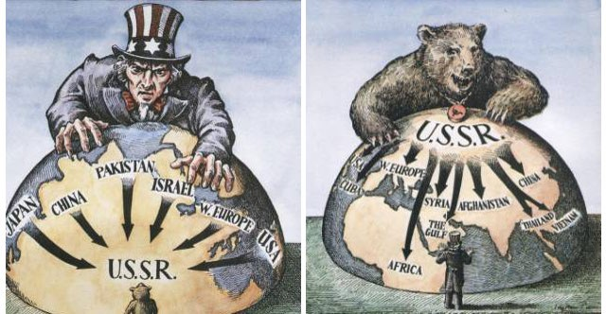
Containment Policy
The Soviet Union controlled the eastern half of Europe after World War II and, despite promises, showed no desire to allow free elections in the area that they controlled. In fact, the Soviets had not withdrawn their military forces back to their own frontiers. These implicit threats of force by the Soviet Union led to a state of tension between the United States and the Soviet Union that became known as the Cold War, which lasted from 1945 through 1991.
The Cold War ushered in a new approach to foreign affairs by the United States. Until the Truman administration, the nation had followed the precedent and recommendation of George Washington to not get involved in entangling alliances. U.S. involvement in wars had, for the most part, been a reluctant last resort. The United States did not take a leadership role in foreign affairs until after World War II. President Truman recognized America's new responsibility to use its vast resources to combat the spread of communism, which would in turn provide greater security for the United States.
Europe was in ruins following World War II. Millions of homes had been destroyed. Factories lay bare to the sky and bombs or fire had destroyed machinery. Rail and road networks were blocked by destroyed bridges and viaducts. The specter of famine stalked much of Europe because of shortages of labor, seed, and farm machinery. The traditional European powers were physically, financially, and emotionally unable to reconstruct the continent.
Truman's policy of containment became the United States’ key foreign policy approach until the fall of the Soviet Union in 1991. While the policy was at first applied to Europe, it was later extended to the Middle East, Asia, Latin America, and Africa. By pledging to protect the world from communist expansionism, the United States in effect became the world's protector from aggression. As a part of the Truman Doctrine, the North Atlantic Treaty Organization (NATO) was created to provide for the mutual defense of Western Europe amid fears of the newly atomic armed USSR. NATO-like treaties were also created with Asia and Pacific nations. This meant an expansion of America's military, economic, and diplomatic presence to all areas of the world.
The Marshall Plan
Truman's Secretary of State, George C. Marshall, proposed a European Recovery Program (later known as the Marshall Plan) to combat the negative economic impacts of World War II in Europe. The plan had two major aims. First, the Marshall Plan aimed to prevent the spread of communism in Western Europe. The second aim was to stabilize the international political order in a way that was favorable for the development of political democracy and free-market economies. Over the Marshall Plan's four-year existence, Congress appropriated $13.3 billion for European recovery. The money aided 22 European nations in their economic recovery by providing much needed capital and assisted American businesses by opening up European markets to American goods. The Eastern European nations were prevented from receiving Marshall Plan money from the United States because they were satellite states of the Soviet Union. The Soviet Union did not want American financial influence threating their control over Eastern Europe. The Marshall Plan's relatively small injection of capital helped to stabilize European politics and enable Western European nations to resist communist infiltration.
The Truman Doctrine
The Truman Doctrine was a new United States foreign policy approach. It was an expression of the United States' belief that communism would infiltrate those areas of Europe that were left weakened by the effects of World War II. In 1946, a civil war broke out in Greece between the democratically elected government and a communist-backed insurgent movement. The British government, that had traditionally supported and protected the Greeks, informed the United States that they were no longer able to assist the Greeks in resisting the communist attempt to take over the nation. Truman then issued a warning to the Soviets that the United States was prepared to use any means necessary to contain communism. Funds were promised to Greece and Turkey to assist in resisting communist take-overs.
Document Analysis 5
The Truman Doctrine Political Cartoon
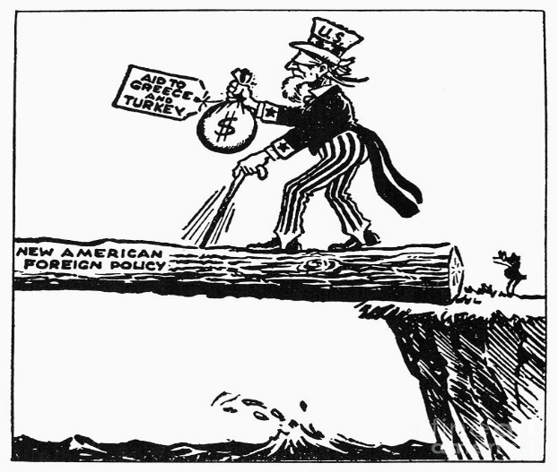
The Korean War
The Truman Doctrine of containment was a success in Western Europe, but was not as effective when applied to Asia in the late 1940s. China was embroiled in an on-again, off-again civil war. The war was between the U.S.-backed Nationalist forces and the Soviet-backed Communist forces. Chiang Kaishek led the Nationalists and Mao Zedong led the Communists in China. In 1949, the Chinese civil war ended in a communist victory. The United States' support of the Nationalists earned the enmity of the Chinese communists, who then controlled the country. The creation of a communist state in Asia also altered the balance of power in the region. U.S. strategists believed that the communist Chinese and the Soviet Union would form a single monolithic communist state, which would threaten the remaining democratic states in Asia.
After World War II, the United States and the Soviet Union agreed to administer the formerly Japanese ruled Korean peninsula under a joint-trusteeship. However, the leaders of the two dominant Korean political parties, the right-wing (U.S. backed) party led by Syngman Rhee and the left-wing (Soviet backed) party led by Kim Il-sung, objected to the trusteeship. Each leader quickly organized his own country with the objective of re-unifying Korea under the image of either democracy or communism. When the United States publicly announced that South Korea was not in the defensive sphere of the United States, Kim Il-sung (with Soviet blessing) launched a war to re-unify South and North Korea in June of 1950.
The fear of a total communist takeover of Asia seemed to be confirmed when North Korea invaded democratic South Korea to begin the Korean War. President Truman and the United Nations extended the policy of containment to Korea. They launched a defense of South Korea. After three years of fighting, the United States and the United Nations forces stabilized the Korean frontier along the 38th Parallel (the original border before the fighting started). No peace treaty has been signed and the armistice is still in place. Hostilities between the two states continue today.
b. Connect major domestic issues to their social effects including the G.I. Bill, Truman’s integration policies, McCarthyism, the National Interstate and Defense Highways Act, and Brown v. Board of Education.
G.I. Bill
Once World War II ended and the Cold War period began, the United States also had domestic issues that needed to be addressed. The containment policy to stop the spread of communism was taken to the extreme within the United States. The nation also needed to address the needs of soldiers returning home and re-entering the workforce. How could the country ensure that widespread unemployment did not cripple the nation once the war production demands of World War II were no longer driving manufacturing? Segregation was another domestic issue that did not fit with the post-war emphasis on preserving freedoms for people around the world. These key issues had significant effects on social change in the United States following World War II.
The G.I. Bill of Rights was passed by Congress to protect and reward returning servicemen. The provisions included giving low interest loans for homes and starting new businesses to former soldiers. Financial grants were also given to the returning soldiers who wanted to attend college. The stimulus of money into housing caused a housing boom characterized by the development of the first suburban housing developments, such as Levittown, New York. The financial investment in returning soldiers stemmed a potential post-war unemployment crisis. Instead, consumer spending expanded as new furniture, appliances, and other household goods were needed. Increased consumer demand became the driving force in the post-war economy and the G.I. Bill helped to foster the surge.
The National Interstate and Defense Highways Act
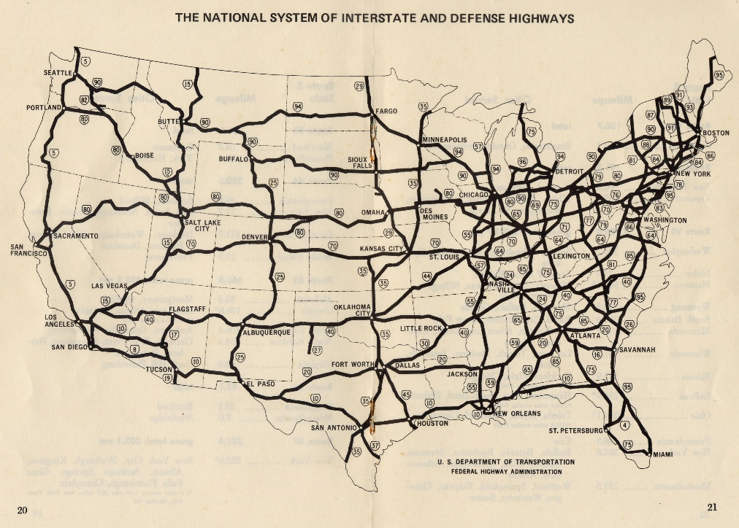
President Eisenhower also wanted to further secure the United States from any future attacks. A prime example of how this domestic issue had a social effect was the government-sponsored creation of infrastructure through the National Interstate and Defense Highways Act, which was passed in 1956. The original purpose of the Act, as envisioned by President Eisenhower, was to create a system of highways for strategic transportation of troops and supplies. As the United States' population grew, the old two lane system of roads connecting communities was proving inadequate. New, wider, more direct routes built across the United States served to link population centers across the nation. As a result, the Interstate Highway Act not only shored up the nation's ability to move military defenses more efficiently, but it also forever changed population patterns and allowed for the growth of suburbia.
Document Analysis 6
“This, ladies and gentlemen, gives you somewhat of a picture of the type of individuals who have been helping to shape our foreign policy. In my opinion the State Department, which is one of the most important government departments, is thoroughly infested with Communist.
I have in my hand 57 cases of individuals who would appear to be either card carrying members or certainly loyal to the Communist Party, but who nevertheless are still helping to shape our foreign policy.
One thing to remember in discussion the Communists in our government is that we are not dealing with spies who get 30 pieces of silver for stealing the blueprints of a new weapon. We are dealing with a far more sinister type of activity because it permits the enemy to guide and shape our policy…”
Source: Senator Joseph R. McCarthy, Speech, February 9, 1950, Wheeling, West Virginia, in Congressional Record, 81st Congress, 2nd Session.
McCarthyism
The fear of communism's infiltration of the United States was another domestic issue that had a significant effect on post-war society. Senator Joseph McCarthy, a Republican from Wisconsin, was looking for an issue to focus on in his re-election campaign. He embraced the post-World War II fear of communism. McCarthy accused the Truman administration of being "soft on communism" and of losing China to the communists. McCarthy further claimed that communist sympathizers had infiltrated the United States’ Department of State. He went on to claim that these traitors were shaping U.S. foreign policy to favor the Soviet Union. Subsequent Senate hearings did not prove McCarthy's charges. In 1953, after Republican Dwight Eisenhower took office, McCarthy launched a wide-ranging series of investigations as the Chairman of the Internal Security Committee. Between April and June 1954, the McCarthy hearings were broadcast to a national audience, which the Senator hoped would propel his national political career. Instead, the hearings destroyed his career. McCarthy made accusations of disloyalty, subversion, and treason without proper regard for evidence. He belittled witnesses and constantly interrupted them to make points of order. "McCarthyism" became a derogatory term for baseless accusations that was popularized by the Senator's overbearing performance.
Truman’s Integration Policies
Another important domestic issue that had a tremendous social impact in the late 1940s and 1950s was segregation. In July 1948, President Harry Truman signed an executive order ending the segregation of the armed forces. Prior to that time period, Black and White soldiers served in separate units. Integration of the Black units with White units did not fully take place until the Korean War in the 1950s. In general, there were three reasons why integration took place. First, there was a growing recognition that segregation undercut the United States' moral stature during the Cold War. Second, there was a need to reduce racial tension within the military. And third, there were significant manpower needs produced by the Korean War. Later studies commissioned by the military found that both Blacks and Whites benefitted from integration. Significantly, integration helped to break down stereotypes so that, as the Civil Rights Movement intensified in the mid-1950s, there was a broad spectrum of Americans who had developed relationships with other races.
The integration of federally contracted jobs and the federal civil service was an evolutionary process. First, in response to pressure from A. Philip Randolph, President Roosevelt issued an executive order in 1941 ending discrimination on jobs that were federally contracted. This measure opened minority employment in defense plants. Next, President Truman banned racial discrimination in the hiring of federal employees and ended segregation in the armed forces in 1948. President Eisenhower issued an executive order that required enforcement of non-discrimination in federal jobs. The Civil Rights Act of 1964 finally barred discrimination in any job and reinforced powers of the Civil Rights Commission to enforce non-discrimination laws.
Brown v. Board of Education
The evolution of integration was boosted by the Brown v. Board of Education decision. The Supreme Court had ruled in the 1896 Plessy v. Ferguson decision that "separate but equal" was the law of the land concerning segregation. In practice this meant that many states had created two systems of public accommodations - one White only, one Black only. In 1951, a Topeka, Kansas parent challenged segregation by suing his local school board. His daughter had to attend the Black elementary school that required her to walk a mile, even though the closest elementary school (White only) was only seven blocks away. The NAACP took on the case but lost on the Plessy precedent. The case was appealed to the Supreme Court. In 1954, the Supreme Court unanimously ruled, "...in the field of public education, the doctrine of 'separate but equal' has no place. Separate educational facilities are inherently unequal."
The Supreme Court ordered that public education be de-segregated, but no timeline was issued and school systems were slow to comply. In response to the Brown decision, Southern states organized the "Massive Resistance" movement, which shut down state education systems rather than integrate the schools. A notable example of this type of action occurred in Little Rock, Arkansas in 1957 when Governor Orval Faubus attempted to use the National Guard to block integration of Central High School. President Eisenhower responded by federalizing the Guard and moving units of the 101st Airborne into Little Rock to enforce the law. Faubus countered by closing Little Rock's schools for a year.
c. Examine the influence of Sputnik on U.S. technological innovations and education.
Document Analysis 7
“Sputnik came as a surprise to most Americans - but it should not have, observes John Logsdon, Director, of the Space Policy Institute, Elliott School of International Affairs at George Washington University in Washington, D.C. ‘Our movies and television programs in the fifties were full of the idea of going into space. What came as a surprise was that it was the Soviet Union that launched the first satellite. It is hard to recall the atmosphere of the time. Fallout shelters, rabid anti- Communism, a sense of imminent danger from without and within,’ Logsdon said. With the launch of the Soviet satellite, Logsdon said, the reaction was more fear than surprise, because it showed clearly that the United States was no longer safe behind its ocean barriers. ‘The claim that who controlled space would control the Earth seemed plausible, and the Soviet Union had taken the first step towards that control’, he said”
Source: Leonard David. (October 2002). Sputnik 1: The Satellite That Started It All. Space.com
Sputnik
On October 4, 1957, the Soviet Union launched the first man-made earth satellite - Sputnik I. Sputnik I was not an unexpected development. United States intelligence had photographed the launch site using spy planes. However, the public and political outcry in America regarding the Soviet success over the United States led to several developments including the following:
1. Dramatic increase in funding for science and math education (National Education Defense Act)
2. Creation of a national space program - National Aeronautics and Space Administration (NASA)
3. Inspired a generation of engineers and scientists to develop new technology, which in turn led to the eventual development of the Internet
4. Contributed to the perception of a "missile gap" between the United States and the Soviet Union. The fear was that the Soviets could use sudden (perceived) superiority in missile technology to launch an attack on the U.S. and its allies.
5. Although he did not create the Cold War, President Eisenhower devised policies to counter the perceived Soviet military threat. His "domino theory" led to American intervention in Vietnam. His "massive retaliation" stance proclaimed that the United States would answer any military attack with all out military and atomic capacity
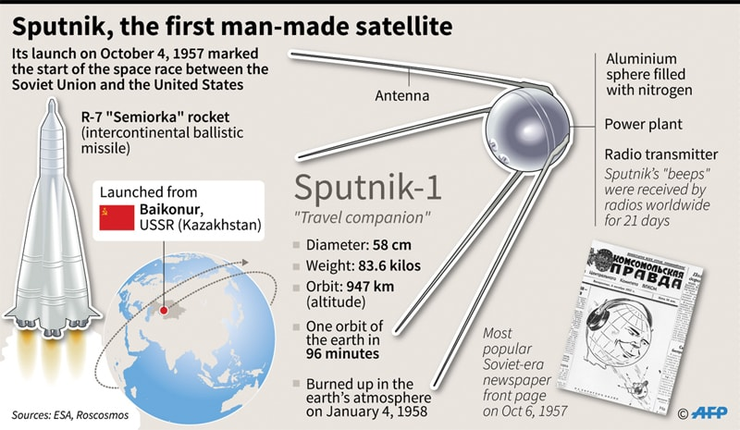
Document Analysis 8

